TABLE OF CONTENTS

PART 1. BACKGROUND OF THE COUNCIL AND STRATEGY 1

EXECUTIVE SUMMARY 1
THE COUNCIL 2
DUTIES AND RESPONSIBILITIES 2
TRUST FUND 2
PURPOSE OF FUNDS 2
THE STATEWIDE STRATEGY 3
OBJECTIVES OF THE STATEWIDE STRATEGY 3
PARTICIPATION IN THE DEVELOPMENT OF THE STATEWIDE STRATEGY 3
PUBLIC INPUT 4
2008 - 2011 STRATEGY DEVELOPMENT 4
SUMMARY OF PUBLIC INPUT ON STRATEGY 4
PUBLIC REVIEW 4
CONCLUSION 4

PART 2. THE NATURE AND EXTENT OF THE MOTOR VEHICLE THEFT PROBLEM IN ILLINOIS 5
MOTOR VEHICLE THEFT DATA SOURCES 5
TYPES OF MOTOR VEHICLE THEFT 6
NATIONWIDE COMPARISONS 8
REGIONAL COMPARISONS 11
MOTOR VEHICLE THEFT IN ILLINOIS 13
CONDITIONS OF RECOVERED MOTOR VEHICLES IN ILLINOIS 2005 16
MOTOR VEHICLE THEFT IN ILLINOIS COUNTIES 17
MOTOR VEHICLE THEFT IN ILLINOIS CITIES 20
PART 3. INPUT ON THE COUNCIL’S STRATEGY 21
SUMMARY OF INPUT AND RECOMMENDATIONS 21
CONCLUSION 25

PART 4. RESPONSE TO MOTOR VEHICLE THEFT IN ILLINOIS 26
PART 5. THE COUNCIL'S FUNDING STRATEGY 28

PRIORITY PROBLEM AREAS 28
WHAT PROGRAMS HAVE BEEN FUNDED BY THE COUNCIL TO ADDRESS THE VEHICLE THEFT PROBLEM? 35
WHAT TYPES OF COSTS ARE COVERED BY TRUST FUNDS? 35
DO GRANTEE'S "MATCH" TRUST FUNDS? 36
TRUST FUNDS AWARDED 1992 - 2006 37
AREAS OF GREATEST NEED 37
ALLOCATION OF TRUST FUNDS FOR 2005-2006 38
CONCLUSIONS 38

APPENDICES
A.THE ILLINOIS MOTOR VEHICLE THEFT PREVENTION ACT
B. PUBLIC INPUT NOTICES
C. FUNDED PROGRAMS
D. 2006 TRUST FUND CONTRIBUTORS

PART 1. Background of the Council and Strategy

Executive Summary

The eleven-member Illinois Motor Vehicle Theft Prevention Council (the Council) was created by statute in 1991 to combat motor vehicle theft in Illinois. Each year it collects and administers special trust funds derived from a $1 assessment on the private passenger insurance policies written by insurers in Illinois. The Council makes grants to those who implement programs to combat or prevent vehicle theft.
To further this mission, the Council adopts a statewide motor vehicle theft prevention strategy every four years derived from public comment, expert opinion, data analyses and the experiences of funded programs. The strategy describes the nature and extent of the vehicle theft problem in Illinois, the areas of the State where the problem is greatest, particular problems that the Council should focus on and the types of programs it should support. Since it began its work in 1991, vehicle theft offenses has dropped significantly statewide, by 44 percent. Motor vehicle theft remains concentrated in the metropolitan areas of Illinois.
The Council’s funded programs have achieved impressive results as witnessed in the increases in the number of arrests, prosecutions, and convictions for vehicle theft and related offenses and reductions in the vehicle theft related offenses in Illinois. Multi-jurisdictional task forces coupled with appropriate prosecutorial resources continue to demonstrate that they are an effective law enforcement approach to vehicle theft.

In the 2008-2011 strategy, the Council continues to support law enforcement “infrastructure” programs a key to long-range planning. Auto theft investigation training programs enable officers across the state to identify and recover stolen vehicles and parts are regarded as a key ingredient to continued success. Likewise, the uniform data collection and dissemination is of critical value to programs fighting vehicle theft and will remain in place in 2008-2011.

The Council awarded 2004-2007 programs based on a look toward the financial future. The $1 assessment collected each year on private passenger vehicle insurance policies is “fixed,” however, the cost to maintain the current programs is estimated to exceed the collection in the near future. With an eye toward this, programs were advised to eliminate all unnecessary expenditures. If grantees could not fill job vacancies within a set time frame, those positions were eliminated from their awards. Every effort was made to pare down already lean programs. The financial situation is more difficult as we enter into the 2008-2011 strategy. While program costs continue to rise, and collections remain relatively stable, mandated transfers from the trust fund to the general revenue fund in FY03 through FY06 have significantly reduced the balance in the trust fund. To continue combating motor vehicle theft, the Council will need to significantly reduce the amount of funds that are granted on an annual basis.

The statewide motor vehicle theft prevention strategy was drafted utilizing the findings of the Council in 2007, available data, and input from practitioners and expert panel members. Due to careful planning and strategizing in 1991 and the ongoing efforts of the Council to keep abreast of the state’s auto theft problem, the strategy focuses the direction of the Council’s efforts for 2008-2011.

The Council

The Illinois Motor Vehicle Theft Prevention Act that took effect on January 1, 1991 created the Illinois Motor Vehicle Theft Prevention Council. The Council has the statutory responsibility to “prevent, combat and reduce motor vehicle theft in Illinois; to improve and support motor vehicle theft law enforcement, prosecution and administration of motor vehicle theft laws by establishing statewide planning capabilities for and coordination of financial resources.”

Duties and responsibilities
The primary duties and responsibilities of the Council are:
< To establish priorities for, allocate, disburse, contract for, and spend funds that are made available to the Council from any source to effectuate the purposes of the Act.

< To make grants and to provide financial support for eligible recipients to effectuate the purposes of the Act.

< To assess the scope of the problem of motor vehicle theft, including particular areas of the State where the problem is greatest and to conduct impact analyses of State and local criminal justice policies, programs, plans and methods for combating the problem.

< To develop and sponsor the implementation of statewide plans and strategies to combat motor vehicle theft and to improve the administration of motor vehicle theft laws and provide an effective forum for identification of critical problems associated with motor vehicle theft.

< To coordinate the development, adoption and implementation of plans and strategies relating to interagency or intergovernmental cooperation with respect to motor vehicle theft law enforcement.

Trust Fund
The Act established the Motor Vehicle Theft Prevention Trust Fund, a special trust fund in the State Treasury, from which the Council makes grants to eligible applicants for programs that address the problem of motor vehicle theft in Illinois.
The Act requires all insurance companies licensed to write private passenger vehicle physical damage coverage included in Class 2 and Class 3 of Section 4 of the Illinois Insurance Code to pay annually into the special trust fund an amount equal to $1.00 for each earned car year of exposure for physical damage insurance coverage during the previous calendar year.
Approximately $6.2 million is deposited into this fund on an annual basis. Since FY03 $5.7 million in transfers have been made from the trust fund to the general revenue fund. Legislation was passed in 2003 assessing a 5% administrative fee to the Trust Fund, resulting in $1.1 million being transferred to the general revenue fund.. Trust Funds may be awarded to federal and State agencies, units of local government, corporations, and neighborhood, community and business organizations.

Purpose of funds
The Act provides that the Council may award these funds:
< To law enforcement and correctional agencies, prosecutors, and the judiciary for programs designed to reduce motor vehicle theft and to improve the administration of motor vehicle theft laws.

< For federal and State agencies, units of local government, corporations and neighborhood, community or business organizations for programs designed to reduce motor vehicle theft and to improve the administration of motor vehicle theft laws.

< To conduct programs designed to inform owners of motor vehicles about the financial and social costs of motor vehicle theft and to suggest to those owners’ methods for preventing motor vehicle theft.

The statewide strategy
Every four years the Council develops the Statewide Motor Vehicle Theft Prevention Strategy. The strategy includes an overview of the motor vehicle theft problem in Illinois including discussions of the nature and extent of the problem, current efforts to address the problem, resource needs, and areas of greatest need within the State. The document also includes a description of the strategy for addressing the problem including the identification of eligible program areas.
Consistent with the statewide strategy, the Council solicits and negotiates program proposals from eligible recipients. The Council gives priority to those eligible recipients with the greatest need. To that end, and based upon the statewide strategy, the following criteria are used to identify those eligible recipients with the greatest need as evidenced by: (1) An analysis of demographic, insurance, and appropriate criminal justice data; (2) Comments from the general public, federal, State, and local officials; and (3) Current research findings.
At public meetings, the Council designates programs, implementing entities, and amounts for funding which address one or more of the purposes consistent with the Act and the statewide strategy. The Council’s decision to designate programs, implementing entities, and fund amounts are based upon consideration of the following factors:
1. The recommendations and advice of its Grant Review Committee;
2. The recommendations of the Executive Director;
3. Comments from the general public, federal, State and local officials;
4. The proven effectiveness of a similar program, by making a prudent assessment of the problem to be addressed by the proposed program;
5. The likelihood that a proposed program will achieve the desired objectives, by making a prudent assessment of the concepts and implementation plans included in a proposed program and by the results of any evaluations, previous tests, or demonstrations;
6. The availability of funds;
7. The overall cost of the proposed program;
8. The implementing entity’s ability to effectively and efficiently carry out the program; and
9. The relation of the proposed program to and impact on other proposals or funded programs.

The statewide strategy is the foundation upon which the State’s efforts to combat motor vehicle theft will be built through the use of Trust Funds granted by the Council.

Objectives of the statewide strategy
The goals of the 2008-2011 Statewide Motor Vehicle Theft Prevention Strategy are to prevent, combat, and reduce motor vehicle theft and fraud related motor vehicle theft in Illinois; and to improve and support motor vehicle theft law enforcement, prosecution, and administration of motor vehicle theft laws by establishing statewide planning capabilities for and coordination of financial resources.
The objectives of the strategy are:
- To reduce the number of motor vehicles stolen in the State;
- To reduce the number of fraud related motor vehicle thefts;
- To increase the number of stolen motor vehicles recovered;
- To increase the percentage of offenses for violations of motor vehicle theft laws that result in arrests;
- To increase the percentage of offenses for violations of motor vehicle theft laws that result in criminal prosecutions;
- To increase the percentage of offenses for violations of motor vehicle theft laws that result in convictions and jail or prison sentences; and
- To reduce the recidivism of motor vehicle theft offenders.

Participation in the development of the statewide strategy
The Council is committed to ensuring that the statewide strategy reflects not only the interests and concerns of those federal, state, and local officials whose duty it is to enforce the criminal laws and to direct the administration of justice in Illinois, but also the views of the insurance industry, neighborhood and community groups, professional organizations, and citizens as well. To that end, the Council undertakes a number of measures to provide ample opportunity for comment on the statewide strategy to combat motor vehicle theft.

Public input
As an aid in the development of the strategy, the Council regularly invites public input to:
< Ensure that all appropriate agencies, units of government, private organizations and combinations thereof are considered in the development of this strategy;

< Aid in the definition of the nature and scope of the motor vehicle theft problem in Illinois;

< Help identify areas of greatest need within the State; and

< Assist in targeting potentially effective programs so that the impact of the Act is maximized.

Witnesses are asked to present oral or written testimony which:
< Identify the most pressing motor vehicle theft-related problem(s) facing their agency, taking into account the purposes of the Act.

< Present statistical data or other information that document the scope and nature of the problem(s).

< Identify the resources presently available to address this (these) problem(s).

< Discuss why a particular approach to the problem(s) show(s) more promise than other approaches.

< Discuss the relevance of recent developments in law enforcement - such as community policing, technological advances, multi-jurisdictional initiatives, etc. - to their agency’s or area’s motor vehicle theft problem(s).

2008-2011 strategy development
As part of the 2008-2011strategy development, in February 2007, the Council solicited written input on its strategy to date and the programs it supports. The solicitation was posted on the web sites of the Illinois Criminal Justice Information Authority, Chiefs of Police Association, Sheriff’s Association and the State’s Attorney’s Association. The solicitation was also mailed to 293 insurance agencies that wrote motor vehicle insurance policies in the state of Illinois (A copy of the notice is contained in Appendix B). Time was set aside at the May 18, 2007 Council meeting for all interested parties to provide verbal or written input on the strategy and the program it funds.

Public review
The strategy itself will be discussed at an open meeting of the Council prior to its approval. Interested officials and citizens who are unable to attend that meeting are notified of their opportunity to read and comment on the strategy via the Council’s web-site, newspaper articles and posting in the state newspaper. A summary of the strategy is also prepared and distributed to the insurance industry, police chiefs, sheriffs, state’s attorneys, and others after approval by the Council.

Conclusion
The Statewide Motor Vehicle Theft Prevention Strategy is the Council’s plan of operation for dealing with vehicle theft in Illinois. It is the result of careful analysis, public comment and review, and thoughtful discussion among stakeholders in the criminal justice community in Illinois.

Part 2: The Nature and Extent of Motor Vehicle Theft

Introduction

This part gives an overview of motor vehicle theft in the United States in general, the regions of the United States with a special concentration on the Midwest, the State of Illinois, counties in Illinois, and individual cities within the state.

Motor Vehicle Theft Data Sources

The following points discuss the data sources mentioned in this part. These sources may report on a variety of topics, but the paragraphs below describe the data these sources provide that are pertinent to this part. The data used in this part was the data most currently available from these sources.

National statistics showing the extent of motor vehicle thefts:
- National Crime Victimization Survey (NCVS): Self-report that collects victimization data and information concerning the circumstances of crime.
- Uniform Crime Reports (UCR): The FBI’s reporting system that collects data on crimes reported to approximately 17,000 city, county, and state law enforcement agencies in the United States. These reports are compiled and analyzed in a yearly publication entitled Crime in the United States.
- The National Insurance Crime Bureau (NICB) partners with insurers and law enforcement agencies to facilitate the identification, detection and prosecution of insurance criminals.
- The Insurance Institute for Highway Safety’s Highway Loss Data Institute (HLDI) studies how to decrease the number of motor vehicle accidents and how to reduce injuries when vehicle accidents do occur.
- The State University of New York at Albany publishes the Sourcebook of Criminal Justice Statistics, bringing together data from various sources about the criminal justice system in the United States.
- CCC Information Services provides the insurance industry with technological support and information services.
- State Farm Insurance is one of the largest insurance-providers in the United States.
- U.S. Census Bureau provided population data, including data on age, sex, race and Hispanic origin.

Local statistics reporting motor vehicle theft in Illinois:
- Law Enforcement Agencies Data System (LEADS): The Illinois State Police LEADS system is a computerized telecommunications system that provides current and valuable crime-related information to the law enforcement agencies and criminal justice community in Illinois. The Motor Vehicle Theft Intelligence Clearinghouse is a Council-funded program that provides analytical support for motor vehicle theft task forces and the Illinois law enforcement community using LEADS and other data sources on all motor vehicles thefts in the state, not simply those occurring in Council-funded task force areas.
- The Illinois Department of Corrections (IDOC) reports on imprisonment and sentence length.
- The Illinois State Police publishes a yearly report based on UCR data, Crime in Illinois, patterned after the FBI’s Crime in the United States.
- The Illinois Secretary of State tracks vehicle registrations for the State of Illinois.

Data Limitations
- Some data are available only at a national or state level, which makes them impossible to compare.
- Illinois does not require data to be reported on juveniles, which prevents an analysis of their involvement in vehicle theft.
- UCR tallies attempted and completed motor vehicle thefts together, whereas LEADS only considers completed motor vehicle thefts in its final figures.

Types of Motor Vehicle Theft

Motor vehicle thefts are committed for a variety of reasons. The literature in the field, as well as public comments suggests that there are four basic motives behind motor vehicle theft:

Joy Riding Theft of a vehicle for the purpose of riding around. These vehicles are usually recovered quickly and close to the location they were stolen from.
Transportation Theft of the vehicle for personal use. The stolen car is usually abandoned at the destination.
Commit Other Crimes Theft of the vehicle for transportation to and from a crime scene. The vehicle is abandoned after the crime has been committed.
Profit/Commercial Thefts Thefts perpetrated for financial gain.

There are several types of commercial theft. The following are the most common types of commercial theft:

- Counterfeit Title- Stolen vehicles can be sold through the use of counterfeit titles. The vehicles are usually sold cheaply and quickly. Frequently the offender will use “out of state” vehicle titles.

- Out-of-State/Non-Title State – There are weak and inconsistent vehicle title laws in the United States. In some states, evidence of ownership may be accomplished by registration certificate and transfer is by bill-of-sale on cars other than those sold as new. Stolen cars are registered in these states, frequently on mailed-in applications for registration documentation. In some states, no evidence of ownership is required on older model vehicles. In these operations, an application is completed which reflects the purchase of the vehicle from a fictitious person in another state. A registration certificate and license plates are obtained. The thief then sells the vehicle with this documentation of "ownership."

- Vehicle Identification Number (VIN) Switching - The intentional alteration of the VIN and the use of the fictitious VIN on counterfeit ownership or registration documents. The vehicle is then sold to an unsuspecting buyer.

- Counterfeit Manufacturers Certificate of Origin - The manufacturer of a new vehicle includes a document with the vehicle to its destination and ultimate sale called a "Manufacturers Certificate of Origin" or MCO. It is frequently referred to as the vehicle's birth certificate. In many states the MCO is the foundation for all subsequent registration and title documents. Counterfeit MCOs are used to misrepresent stolen vehicles as "new".

- Salvage Switches - These methods involve the purchase of salvage vehicles (wrecked) from insurance companies or auto wreckers. The salvage is usually dismantled but the VIN plate, license plates, title, or bill-of-sale is retained. A vehicle of similar make and model is stolen and the identity of the salvage vehicle is transferred to it. The stolen vehicle is then sold under this identity.

- Key Cuts - The offender locates a vehicle he would like to steal and obtains the public VIN from the vehicle. The offender will then go to a dealership with this information and request that a key is made for that particular vehicle. When supplying a reason, the offender usually claims he lost his keys.

- Importation Operations - These methods involve organized rings importing high-priced stolen European cars into the U.S. Again, inconsistent and sometimes ineffective foreign titling and registration laws are taken advantage of by these rings.

- Chop Shops – Chop shops are places where stolen cars are dismantled for parts and accessories that can be sold for profit. Sometimes parts are purchased by body shops or repair garages for repairs to damaged vehicles.

- Identity Theft – Identity theft occurs when someone uses personal information such as your name, social security number, or bank account number without your knowledge to commit fraud or theft. Identity thieves can purchase vehicles using the personal information of an unsuspecting victim. The victim may not receive any indication of the purchase until three months after the car has been purchased, which is usually a late payment inquiry from the finance company.
- Vehicle Cloning – A thief will copy a VIN from a legally owned vehicle sitting in a parking lot or vehicle dealership. Then the offender will steal a vehicle similar to the one from which the criminal copied the VIN. The stolen vehicle’s legitimate VIN tag is then replaced with the counterfeit one.

- Insurance Frauds - These methods involve making false vehicle theft reports for the purpose of defrauding insurance companies. Frauds can be simple or complex and elaborate schemes.

a. Simple Insurance Frauds

Simple frauds are generally considered to be afterthoughts as opposed to highly sophisticated schemes. For example, a simple fraud may be invented to cover up some other criminal offense. Sometimes allegations are made that a vehicle was stolen in order to provide an alibi in hit-and-run, drunken driving, or other offenses. Frequently, a person wrecks a vehicle and determines that a traffic accident investigation would prove risky because of his condition or the contents of the vehicle would not stand close inspection. Sometimes a fraud is committed when a vehicle owner recovers the vehicle himself but neglects to advise the insurance company, which has already compensated him. Other frauds, referred to as "Owner Give-Ups", are arranged by the vehicle owner who reaches an agreement with an accomplice to leave the vehicle and keys at a certain location. These arrangements result in the vehicle being:

    - Reported stolen and recovered stripped. This way the damaged or worn-out parts are replaced via the insurance settlement.

    - Reported stolen and recovered stripped and burned. In addition to the insurance settlement, stripped parts are sold for profit.

    - Reported stolen and not recovered.

There have also been frauds committed by vehicle owners who abandon vehicles in locations with the hope that the vehicle is stripped or stolen. Shortly after, the owner reports the vehicle stolen to the police and insurance company.

b. Complex Insurance Frauds

Complex frauds are well-planned schemes that may involve thousands of dollars. These frauds generally fall within one of four types:

1. Duplicate Title Frauds - In these kinds of frauds, the insured person sells the vehicle, obtains a duplicate vehicle title, reports the vehicle stolen, and then surrenders the duplicate title to the insurance company. This method nets proceeds from the sale of the vehicle and the vehicle theft settlement from the insurance company.

2. Counterfeit Title Frauds - In these kinds of frauds, usually a heavily financed vehicle is reported stolen and the insured presents his insurance company with a counterfeit title listing himself as the sole owner (omitting the bank or finance company as a lien).

3. Paper Vehicle Frauds - There are some states and provinces in the United States and Canada that do not have adequate vehicle title laws. Evidence of ownership is by registration certificate and transfer is by bill-of-sale on older vehicles. There is generally no inspection of the vehicle to determine the validity of the VIN and other registration information. In some instances, registrations are issued on the basis of mailed-in applications. Upon receipt of the registration, application is then made to a state issuing a title (but usually not a vehicle inspection). With title in hand, the fictitious vehicle is then insured. The final step is the theft report on the paper vehicle to the police and insurance company.

4. Salvage Vehicle Frauds - These frauds are similar to paper vehicle frauds except that they involve actual vehicles sold as salvage. These vehicles are registered and titled as "operational", insured, and then reported stolen.

The National Insurance Crime Bureau estimates that 10 percent of all reported vehicle thefts are fraudulent. Other estimates reach as high as 30 percent.

Carjacking

Carjacking, also referred to as vehicular hijacking, is the theft of a vehicle through the means of force. A significant amount of media attention has been focused on this type of vehicle theft since it presents the most harm to the victim. Statistical information regarding the occurrence of these crimes is problematic. Some law enforcement agencies record these incidents as robberies, or strong-armed robberies but others do not. As a type of motor vehicle theft, these crimes would typically fall into the "joyriding" or "for transportation" category because most often vehicles are recovered intact.

Nationwide Comparisons

According to the FBI, in 2005, approximately 1.2 million vehicles were stolen in the United States, indicating that a vehicle was stolen every 26 seconds in the United States that year. The United State experienced a 2% decrease in motor vehicle thefts from 2004 to 2005. The Illinois rate decreased approximately 3 percent during the same period, from 322.4 to 312.7 offenses per 100,000 persons in the population as reported in Crime in Illinois, 2005. Also in 2005, approximately 323.2 automobiles and 77.8 trucks or buses were stolen for every 100,000 persons in the population, and according to the Sourcebook for Criminal Justice Statistics, one vehicle was stolen for every 188 vehicles registered in the United States.

As Table 1 indicates, reported motor vehicle thefts increased across the country each year from 2001 to 2003, but decreased in 2004 and 2005.

Table 1:
National Motor Vehicle Theft Trends, 2001 – 2005
 | TOTAL MOTOR |  | CHANGE IN RATE
YEAR | VEHICLE THEFTS | RATE PER  100,000 PERSONS | FROM PREVIOUS YEAR
2001 | 1,228,391 | 430.5 | 4.4
2002 | 1,246,646 | 432.5 | .01
2003 | 1,261,226 | 433.7 | .002
2004 | 1,237,851 | 421.5 | -03
2005 | 1,235,226 | 416.7 | -.01
Source: Crime in the United States, Federal Bureau of Investigation

From 1996 through 2005, the United States experienced a 21 percent decrease overall in the vehicle theft rate, as reported by the FBI. During this time, the motor vehicle theft rate in Illinois decreased approximately 35 percent, from 478.3 to 311.4 offenses per 100,000 persons in the population as reported in Crime in Illinois.

Washington, DC had the highest motor vehicle theft rate in the United States in 2005. Among the ten states with the highest motor vehicle theft rates, western states were more represented than states from any other region. Illinois ranked 28th.

Table 2:
Ten States with the Highest Motor Vehicle
Theft Rates and Illinois State’s Ranking, 2005
 |  | RATE PER
RANK | STATE | 100,000 PERSONS
1 | Washington, DC | 1402.3
2 | Nevada | 1115.2
3 | Arizona | 924.4
4 | Washington | 783.9
5 | Hawaii | 716.4
6 | California | 712.8
7 | Maryland | 608.4
8 | Colorado | 559.5
9 | Oregon | 529.0
10 | Georgia | 490.2
28 | Illinois | 308.6
Source: Crime in the United States, Federal Bureau of Investigation

Table 3 depicts the ten metropolitan statistical areas (MSAs) with the highest motor vehicle theft rates per 100,000 persons in 2005. MSAs are major metropolitan areas established by the United States Census Bureau, representing not only cities and adjacent metropolitan regions, but also border areas. The City of Chicago MSA ranked 75th in motor vehicle theft rates that year.

Table 3:
Ten MSAs with the Highest Motor
Vehicle Theft Rates and the City
of Chicago’s Ranking, 2005
RANK | CITY
1 | Modesto, California
2 | Las Vegas/Paradise, Nevada
3 | Stockton-Lodi, California
4 | Phoenix/Mesa/Scottsdale, Arizona
5 | Visalia/Porterville, California
6 | Seattle/Tacoma/Bellevue, Washington
7 | Sacramento/Arden-Arcade/Roseville, California
8 | San Diego/Carlsbad/San Marcos, California
9 | Fresno, California
10 | Yakima, Washington
75 | Chicago, Illinois
Source: National Insurance Crime Bureau

The majority of MSAs with the highest motor vehicle theft rates are in the western states of the nation. Further, the National Insurance Crime Bureau (NICB) reports that nine of the top ten metropolitan areas for vehicle theft are in or near ports and Canadian and Mexican borders, indicating that a motive behind motor vehicle theft may be illegal exporting. The NICB

estimates that approximately 200,000 stolen vehicles are illegally exported out of the country each year, and that trafficking in stolen motor vehicles is the second most profitable criminal activity behind drug-dealing.

It is important to note here that the City of Chicago, which accounted for 57 percent of statewide motor vehicle thefts in 2005, is 500 miles from Toronto, Canada’s largest city.

Motor vehicle theft is the most costly property crime in the United States. Twelve percent of property crimes in the United States in 2005 were motor vehicle thefts. In 2005, the cost of vehicle theft to consumers was more than 6 billion annually.

According to the National Crime Victimization Survey: Criminal Victimization 2005, Changes, among property crimes, motor vehicle theft was the most highly reported to police. The number of motor vehicle thefts in the country in 2005 was 8.4 for every 1,000 households. In 2004, there were eight motor vehicle thefts for every 1,000 white households, 16 motor vehicle thefts for every 1,000 black households, seven vehicle thefts for every 1,000 non-Hispanic households of all races, and 20 auto thefts for Hispanic households of all races.

According to a 2005 study by the Insurance Institute for Highway Safety, the Cadillac Escalade, large luxury SUV, had the most insurance theft losses and claims among 2003-2005 models.

Table 4:
Passenger Vehicles with the Highest
Theft Claim Frequencies, 2003-2005 Models
 |  | CLAIMS PER 1,000
MAKE/SERIES | SIZE/TYPE | INSURED VEHICLE YEARS
Cadillac Escalade | Large luxury SUV | 13.2
Mitsubishi Lancer Evolution 4WD | Small 4-Door Car | 11.9
Dodge Ram 1500 quad cab | Large pickup truck | 11.1
Ford F-250/350 supercrew 4WD (2005s) | Very large pickup truck | 8.9
Chrysler Sebring (2004-2005s) | Midsize 4-door car | 8.5
Chrysler 300M | Large 4-Door Car | 5.9

Source: Insurance Institute for Highway Safety, Highway Loss Data Institute

Table 5 lists the ten most stolen vehicles in the United States in 2005, which, in general, are also the most popular vehicles on the road. Tables 4 and 5 differ because the Insurance Institute for Highway Safety determines the vehicles with the worst theft losses by comparing the number of theft claims by make and model relative to the number of each make and model insured.

Table 5:
Ten Most Stolen Vehicles
in the United States, 2005
RANK | YEAR | MAKE | MODEL
1 | 1989 | Toyota | Camry
2 | 1990 | Toyota | Camry
3 | 1991 | Toyota | Camry
4 | 1988 | Toyota | Camry
5 | 1997 | Ford | F-150 4X2 Pickup
6 | 1994 | Honda | Accord EX
7 | 1995 | Honda | Accord EX
8 | 1996 | Honda | LX
9 | 1990 | Honda | Accord EX
10 | 1994 | Honda | Accord LX
Source: National Insurance Crime Bureau

The FBI estimated that the average value of a stolen vehicle in 2005 was $6,173. There was an estimated total of $7.6 billion dollars stolen in 2005. Approximately 62% of those vehicles were recovered

According to the FBI’s Crime in the United States, 2005, police officers arrested 82,160 offenders for motor vehicle theft. Thirty-four percent of those arrested were under the age of 18, and a similar proportion, 25 percent, of the population at large in the United States is under the age of 18 in the year 2005.

In 2005, 24 percent of those arrested for motor vehicle theft in the United States were under the age of 18; 25 percent of the population at large was under the age of 18 in 2005.

In 2005, 82 percent of motor vehicle theft arrestees were male. In 2005, males comprised 49 percent of the population of the United States. In 2005, 62 percent of motor vehicle theft arrestees were white, and 34 percent were black, while 75 percent of the population was white and 12 percent was black in the year 2005. In 2004, eighty percent of the population in the United States was white and 12 percent was black.

Regional Comparisons

From 2004 to 2005, two of the four regions in the United States reported an increase in the vehicle theft rate. Approximately 38 percent of vehicle thefts occurred in the Southern Region and 33 percent occurred in the Western Region. The Midwest Region accounts for approximately 18 percent of the vehicle thefts and 11 percent occur in the Northeast Region. The Western States experienced the greatest increase in the vehicle theft rate with a 4.5 percent increase, while the Midwest Region increased 0.4 percent, and the Southern Region decreased 2.3 percent. The Northeast Region’s vehicle theft rate decreased 9.5 percent during this time period.

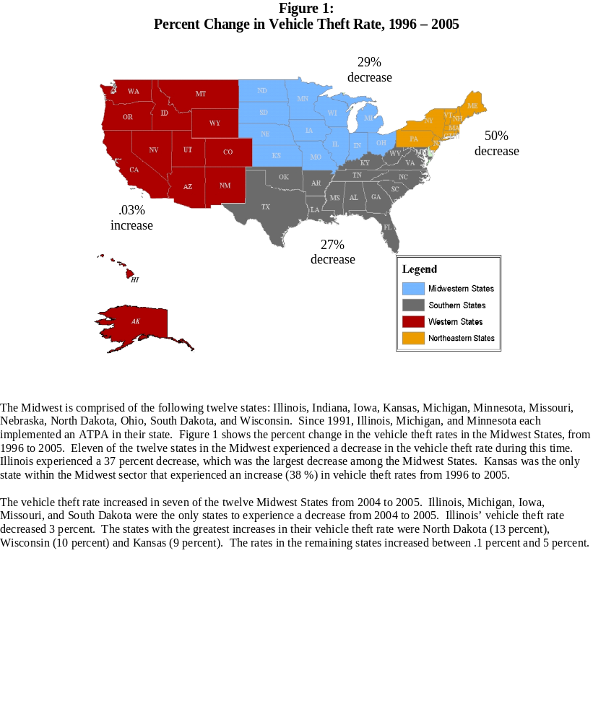

Figure 2:
% Change in Vehicle Theft Rate, 2004-2005

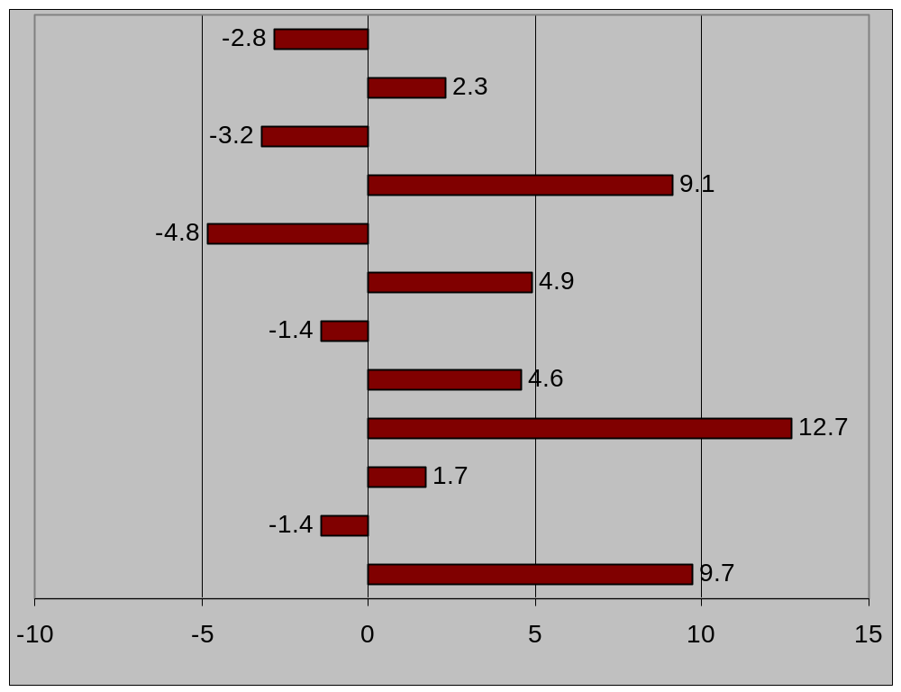
Illinois

Indiana
Iowa
Kansas
Michigan
Minnesota
Missouri
Nebraska
North Dakota
Ohio
South Dakota
Wisconsin

Motor Vehicle Theft in the State of Illinois

Illinois, covering an area of 57,918 square miles, is the 24th largest state in the nation in terms of area. With a population of 12,763,371 in 2005, Illinois is the 5th most populous state in the country. Extending approximately 385 miles from north to south and 218 miles across at its widest point, Illinois is a complex mixture of large urban population centers and vast rural areas. Eighty-six percent of Illinois residents live in urban areas.

Illinois has a major population center home to more than 65% of the State’s 12.8 million residents. This population center includes the City of Chicago, Cook County, and the collar counties, DuPage, Kane, Lake, McHenry, and Will.

In the year 2005, the City of Chicago had 2,842,518 residents, 22% of the statewide population. The City of Chicago is in Cook County that, in 2005, boasted a population of 5,206,357 residents. The five collar counties accounted for 3,010,844 additional residents. The remainder of the state accounted for 4,545,170 persons, or 36 percent of its total population, dispersed among 96 counties ranging in population from approximately 4,000 to 280,000 residents.

According to the U.S. Census Bureau, in the year 2006 75 percent of the state population was white, 12 percent was black, and the remainder was comprised of other racial groups. Fifteen percent of all Illinois’ racial groups were ethnically Hispanic. Twenty-six percent of Illinois residents were under the age of 18, and 49 percent were male.

Although the breakdown was not available for Illinois, in the United States in 2005, 24 percent of those arrested for auto theft were below the age of 18, 71 percent were male and 63 percent were white. Whites and males are the most represented among those arrested for auto theft in the United States, although vehicle theft arrestees are increasingly older and more of them are female. Those arrested in Illinois for auto theft likely display a similar pattern to those found among vehicle theft arrestees in the United States, especially because the proportion of racial groups, males and females, and those under 18 are similar in Illinois and the United States.
The City of Chicago accounts for 23 percent of the State’s population, 14 percent of vehicle registrations and 57 percent of the state’s motor vehicle thefts. Suburban Cook County and Cook County as a whole had slightly larger percentages of vehicle registrations for trucks than was true for Chicago. Vehicle registrations in all counties in the state excluding Cook and the collar counties accounted for 47 percent of all registrations.

Eighty-two percent of state vehicle registrations are for automobiles, 15 percent are for trucks and 3 percent are for motorcycles. Automobiles are the most frequently stolen type of motor vehicle in the state and in the United States.

Table 6:
Motor Vehicle Registrations in Illinois, 2005
 | PASSENGER
AREA | CARS | TRUCKS | MOTORCYCLES | TOTAL
City of Chicago | 1,139,592 | 52,940 | 19,919 | 1,212,451
Suburban Cook | 547,071 | 84,257 | 22,163 | 653,491
Cook County | 1,686,663 | 137,197 | 42,082 | 1,865,942
DuPage | 661,420 | 64,763 | 19,998 | 746,181
Kane | 271,718 | 45,209 | 11,324 | 328,251
Lake | 446,454 | 53,126 | 16,567 | 516,147
McHenry | 189,198 | 34,867 | 11,128 | 235,193
Will | 358,572 | 60,763 | 15,941 | 435,276
Collar Counties | 1,927,362 | 258,728 | 74,958 | 2,261,048
State Minus Cook and Collar | 3,596,115 | 940,756 | 155,140 | 4,692,011
State Minus Cook | 5,523,477 | 1,199,484 | 230,026 | 6,952,987
State | 7,210,140 | 1,336,681 | 272,180 | 8,819,001
Source: Illinois Secretary of State

Table 7:
Percent of Motor Vehicle Registrations in Illinois by Vehicle Type, 2005
 | PASSENGER
AREA | CARS | TRUCKS | MOTORCYCLES
City of Chicago | 94% | 4% | 2%
Suburban Cook | 84% | 13% | 3%
Cook County | 90% | 7% | 2%
Collar Counties | 85% | 11% | 3%
State Minus Cook and Collar | 77% | 20% | 3%
State Minus Cook | 79% | 17% | 3%
State | 82% | 15% | 3%
Source: Illinois Secretary of State

Illinois ranked 28th for vehicle theft rates per 100,000 persons in 2005 when compared to the other states. This is lower than in past years: In 2003, Illinois ranked 8th and the state ranked 10th in 2004, as reported by the FBI. According to Crime in Illinois, the rate of motor vehicle thefts in Illinois has steadily declined since 2000. Over the last ten years, from 1996 to 2005, the motor vehicle theft rate in Illinois declined 40 percent.

Figure 3:

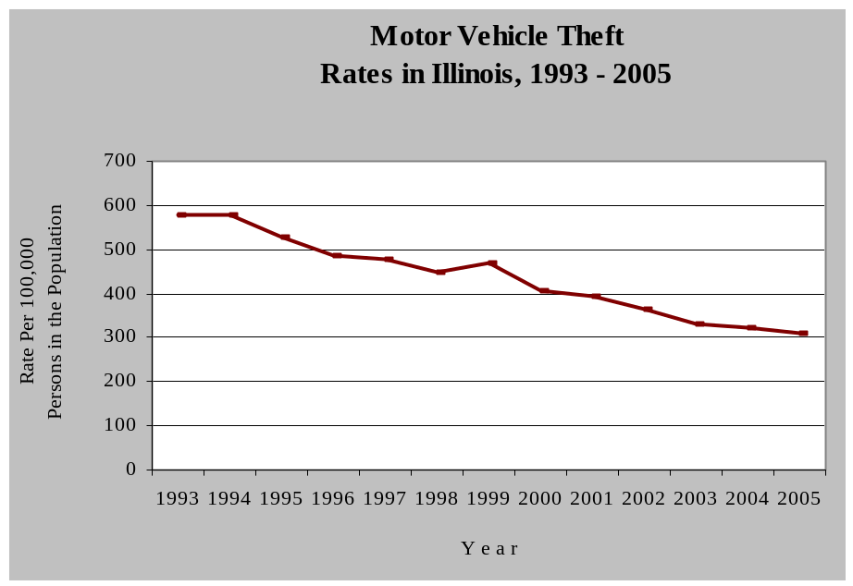
Source: Illinois State Police, Crime in Illinois

In 2005, seven of the top ten vehicles stolen were automobiles; of the remaining top ten vehicles stolen, two were vans and one was a conventional cab. In 2004, only two automobiles made the top ten list of stolen motor vehicles. The remaining vehicles listed in 2004 consisted of three vans, three SUVs and two pick-up trucks. All vehicles on 2005’s top ten list were models dating from 1991 to 2005. In 2005, vehicles with the model year 1995 were the most frequently stolen.

Table 8:
Ten Most Stolen Vehicles
in Illinois, 2004 and 2005
2004 | 2005
Chevrolet Van | Chevrolet Van
Chevrolet SUV | Oldsmobile Cutlass
Dodge Van | Toyota Camry
Ford Van | Ford Taurus
Chevrolet Pick-up | Chevrolet Cavalier
Jeep SUV | Buick LeSabre
Oldsmobile Cutlass | Dodge Intrepid
Ford Pick-up | Honda Civic
Toyota Camry | Chevrolet Conventional Cab
Ford SUV | Plymouth Voyager
Source: Motor Vehicle Theft Intelligence Clearinghouse

Approximately $257 million dollars in vehicles were stolen in Illinois during 2005. From 1991 to 2002, the Council funded about 30 vehicle theft programs in Illinois, spending approximately $66 million. It is important to note that during this time period, Council-funded programs saved $328 million in recovered stolen vehicles and reduced theft rates. From 1996 to 2005, Council-funded task forces recovered 14,724 stolen vehicles.
According to the Motor Vehicle Theft Intelligence Clearinghouse, in 2004 79 percent of stolen vehicles were recovered; this dropped to 75 percent in 2005. The number of recoveries of stolen motor vehicles decreases each year. However, this is perhaps due to the greater length of time available for recoveries for motor vehicle thefts from past years, and not to a real decline in the recovery rate.

In 2006, the average span of time between theft and recovery of a stolen motor vehicle was 18 days. In both 2005 and 2004 only 3 percent of stolen vehicles were recovered out-of-state, the remainder were recovered within the state. The overwhelming majority of recovered stolen motor vehicles were not damaged.

Figure 4:
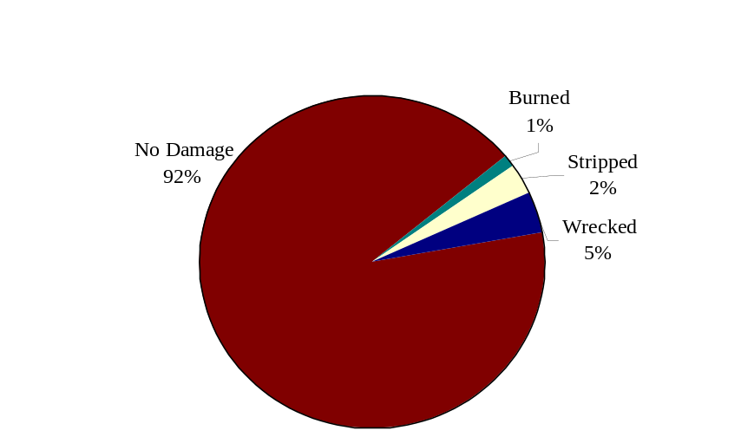Conditions of Recovered Stolen Motor Vehicles in Illinois, 2005

Source: Motor Vehicle Theft Intelligence Clearinghouse

The conditions of recovered stolen motor vehicles may indicate the purpose for which the vehicle was stolen. For instance, a stripped vehicle was likely stolen for parts and a burned vehicle may suggest that the owner is attempting insurance fraud.

Of the 147,456 arrests reported to the FBI for vehicle theft in the United States in 2005, five percent were reported in Illinois (7,011 arrests). Arrest in Illinois for motor vehicle theft decreased 2% from 1996 (10,807) to 2005 (8,645), despite reaching its highest point of 13,697 arrests in 1999. Between 2000 and 2005, motor vehicle theft decreased 39%. During this time period, arrests for motor vehicle theft in the United States decreased 11.4 percent.

In 2004, the average sentence length of the 768 offenders committed to the Illinois Department of Corrections for motor vehicle theft-related crimes was 4.1 years. Although the total number of motor vehicle theft sentences imposed in 2004 declined by 4 percent, the average sentence length increased from 4.0 to 4.1 years.

In 2005, as described in Crime in Illinois, 2005, motor vehicle thefts comprised 10 percent of all property crimes in Illinois; from 2001 to 2005, this proportion was similar.

Illinois Counties

In 2005, the following 10 Illinois counties have the highest motor vehicle theft rates in the state: Cook, Peoria, St. Clair, Winnebago, Alexander, Madison, Massac, Marion, Sangamon and Macon. All of these counties except Peoria, Marion and Macon experienced a decrease in the motor vehicle theft rate from 2004 to 2005. Council-funded motor vehicle theft task forces cover all of these counties except Sangamon, Alexander, Massac, Marion and Mocon.

Of the counties in Illinois covered by the motor vehicle theft task forces, Boone, Kane and Peoria counties experienced an increase in motor vehicle theft rates from 2004 to 2005. Boone County’s auto theft rate rose by 13 percent, Kane county rate rose by 10% and Peoria county rate rose by 20%, during this time.

Table 9:
% Change in the Motor Vehicle Theft
Rate of Council-Funded Motor Vehicle
Theft Prevention Task Forces, 2004 to 2005
COUNTY | 2004 | 2005 | % CHANGE
Boone | 94.90 | 106.97 | 13%
Cook | 562.03 | 550.67 | -2%
DuPage | 90.83 | 83.84 | -8%
Grundy | 102.00 | 70.71 | -31%
Kane | 105.82 | 166.56 | 10%
Kankakee | 133.60 | 125.03 | -6%
Madison | 259.26 | 245.92 | -5%
Peoria | 413.44 | 497.46 | 20%
St. Clair | 466.57 | 446.42 | -4%
Will | 101.38 | 97.23 | 0%
Winnebago | 480.29 | 419.47 | -13%
Source: Motor Vehicle Theft Intelligence Clearinghouse

According to the Illinois State Police, Cook County accounted for 26% of all motor vehicle thefts in Illinois in 2005, and the City of Chicago accounted for 77 percent of thefts in Cook County.

Table 10:
Percentage of Statewide Motor
Vehicle Thefts by County Type, 2005
AREA | 2005
City of Chicago | 57%
Suburban Cook | 17%
Cook County Total | 74%
Collar Counties | 7%
Urban Counties | 15%
Rural Counties | 4%
Source: Illinois State Police, Crime in Illinois, 2005

Between 2004 and 2005, forty-eight of Illinois counties not covered by motor vehicle theft prevention task forces experienced a decrease in auto theft, 37 counties experienced an increase and ten counties had no change. Nine Illinois counties not served by task forces experienced a 100 percent or greater increase in motor vehicle theft from 2004 to 2005, Carroll, Gallatin, Jo Davies, McDonough, Menard, Moultrie, Pope, Scott and Union (Figure 5).

Figure 5:
2004 - 2005 Increases in Motor Vehicle Theft Rates
in Illinois Counties Not Covered by Task Forces
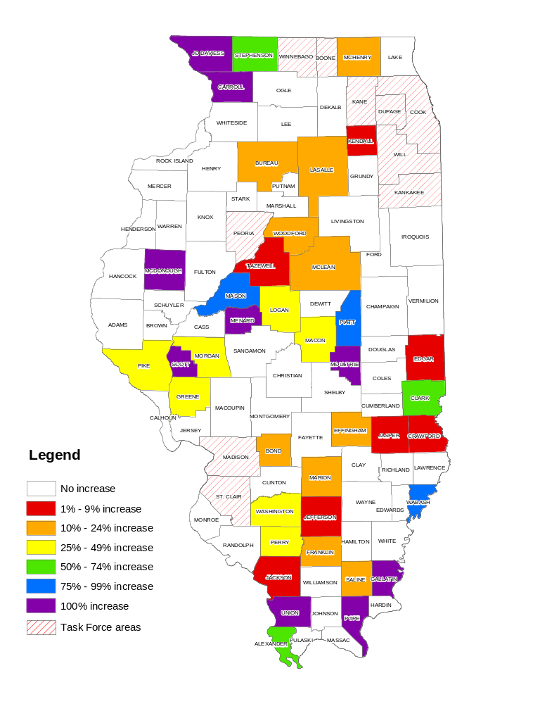
Source: Motor Vehicle Theft Intelligence Clearinghouse
According to the Motor Vehicle Theft Intelligence Clearinghouse, in 2005 Illinois recovered stolen vehicles in, on average, 75 percent of the cases. In that same year, counties covered by Council-funded task forces recovered an average of 74 percent of vehicles reported stolen. In 2002, Cook County’s recovery rate was 83 percent.

Illinois Cities

The City of Chicago has the highest number of motor vehicle thefts in the state. In 2005, motor vehicle thefts in Chicago comprised 63 percent of statewide vehicle thefts. Table 11 depicts the ten cities in Illinois with the highest motor vehicle theft rates in 2005, and the percentage that thefts in these cities comprise of the statewide total.

Table 11:
Ten Illinois Cities with the
Highest Motor Vehicle Thefts, and
Their Percentage of the State Total, 2005
CITY | PERCENT
Chicago | 63%
Rockford | 2%
Peoria | 1%
Harvey | 1%
Cicero | 1%
E. St. Louis | 1%
Joliet | 1%
Calumet City | 1%
Springfield | 1%
Aurora | 1%
Source: Motor Vehicle Theft Intelligence Clearinghouse

Typically, cities with the highest motor vehicle theft rates also have the highest recovery rates. Table 12 lists the Illinois cities with the highest stolen motor vehicle recovery rates.
Table 12:
Ten Illinois Cities with the Highest
Stolen Motor Vehicle Thefts Recoveries, 2005
 | PERCENT
CITY | RECOVERED
Chicago | 75%
Rockford | 83%
Peoria | 92%
Harvey | 83%
Cicero | 81%
E. St. Louis | 77%
Joliet | 76%
Calumet City | 75%
Springfield | 87%
Aurora | 87%
Source: Motor Vehicle Theft Intelligence Clearinghouse

All of the cities in Tables 11 and 12 are in areas covered by Council-funded task forces except the City of Springfield.

PART 3. INPUT ON THE COUNCIL’S STRATEGY
The following is a summary of input received during the development of the current and previous strategies that is still considered relevant today.

Vehicle theft in Illinois
- The data indicates motor vehicle theft in Chicago is a serious problem that drives the theft rate in the rest of the state.
- Generally, motor vehicle theft is about four times higher in those counties covered by task forces than those counties not served by task forces. Thus, the need for units in those counties.
- The Council should work with the Secretary of State’s office to address problem areas in titling and registering heavy construction equipment; these vehicles should be registered with the state.
- The Council should investigate statutory language changes that would allow the use of statewide grand juries to investigate auto theft rings that cross county lines.
- The Council should investigate clarification of the language regarding information sharing in the existing statutes regarding immunity and the mandatory reporting of suspected insurance fraud.
- Multi-jurisdictional task forces with dedicated prosecutors have an impact on motor vehicle theft. The Council’s focus on areas of greatest need is still relevant and appropriate for future consideration.
- The task forces should increase communications with and work more closely with the Special Investigative Units of insurance companies.
- Diffuse geographical areas experience different types of vehicle theft problems; there is no single solution that can be applied unilaterally across the state.
- Automobile theft rates are declining across the state but there are pockets where it is rising. The Council should work to identify layers of assistance to be provided to areas not covered by task forces. This could include: educational activities, public awareness, VIN etching and short-term projects with local law enforcement.

Recovery conditions
- Task forces are increasingly investigating farm equipment and construction equipment thefts. While the actual numbers of recoveries of these are low, each piece of equipment generally has a high value. The Illinois State Police Motor Vehicle Theft Intelligence Clearinghouse has and should continue to issue “Alerts” to the task forces as to how to identify construction equipment and to raise their awareness of these thefts.
- In 2005, 91 percent of recovered vehicles were recovered with no damage. Three percent were recovered stripped and one percent was recovered burned.
- In 2002, the average number of days for a vehicle to be recovered after it was stolen was 17 days.
- Air bags have become a prime accessory for illicit vehicle parts. A new air bag, which retails for approximately $1,000 from a dealer costs between $50 to $200 on the illicit market.
- Approximately 25 percent of the 41,705 vehicles stolen in Illinois in 2005 were not recovered. Organized criminal elements involved in auto theft are suspected of exporting many of these vehicles. The top vehicle not recovered was the Chevrolet Van.

Data quality issues affecting auto theft
- Uniformity in motor vehicle data collection at a statewide level is of paramount importance. Efforts to utilize forms have improved.
- Computerized mapping and intelligence sharing through the Clearinghouse should continue to focus on auto theft trends, such as the discovery that the majority of cars stolen from DuPage County are recovered in Chicago, and many are found in gang territory on the city’s west side.
- Through geographical mapping, the locations of certain junkyards, streetlights, bushes, auto repair stores and other places are related to where vehicles have been stolen and recovered.
- The top eleven counties of motor vehicle theft include the areas where the Council has task forces, which supports their continued use in these locales.
- Although the accuracy of auto theft information being reported has increased, the Council should work to further improve the accuracy of the information.

Insurance Fraud
- The insurance industry reports that 10 percent of auto thefts are due to owner’s fraud. This figure represents individual owners who are experiencing financial difficulty or mechanical trouble with the vehicle and wish to report the car stolen, but are not the organized type of “give up,” which drives the rate to perhaps 25 percent. Organized “give-ups” occur when the owner of the vehicle voluntarily exchanges the vehicle for illegal drugs with a drug dealer. The drug dealer then operates the vehicle for a period of time and the owner later reports the car as stolen.
- The percentage of prosecutions of auto theft related fraud is low, approximately 5 percent of fraudulent claims, due to the difficulty in proving the fraud.
- Since a contributing cause to insurance fraud vehicle thefts is the ease of reporting a vehicle stolen to law enforcement, the Council should support in-person reporting if feasible. Vehicle owners who are claiming theft should have to sign a police document or report acknowledging the commission of a criminal act if found to have given false information.
- The task forces, Clearinghouse, task forces and National Insurance Crime Bureau, or NICB, and the insurance and allied industries are addressing and will continue to address the impact of insurance fraud. The NICB is a non-profit organization supported by approximately 1,000 insurance and self-insured companies dedicated to fighting insurance-related crime. A continued partnership between these allies will enable the statewide initiative to identify insurance fraud and apprehend offenders.
- The insurance industry should pass information of suspected owner “give ups,” where the vehicle owner disposes of the vehicle and files a claim for theft, along to the Council’s task forces. The industry should also give this information to the NICB. In turn, the task forces should give each suspected fraud serious attention.
- The auto theft task force directors have been successful in instilling in their officers the importance of looking at each auto theft case as a possible insurance fraud.
- Law enforcement would be greatly helped by information on multiple fraud claims made by single individuals. Linkage of insurance information systems to task force data would assist law enforcement greatly.
- The Council, task forces, Clearinghouse, and the NICB continue to work together with the insurance industry to raise insurer investigator awareness about Illinois reporting statutes. These statutes require insurance companies to report suspected motor vehicle fraud to a law enforcement agency. A legislative work group should be formed to discuss how to clarify which law enforcement agency is appropriate to report suspected fraud.
- There needs to be more emphasis on marking vehicle parts to trace their movements to assist law enforcement.
- The Council should seek to determine what percentage of vehicles reported as stolen is being submitted for insurance claims.

Carjacking/ Vehicular Hijacking
- Carjacking accounts for less than two percent of Illinois auto theft.
- The Federal Anti-Car Theft Act of 1992 (FACTA) makes carjacking a federal offense, punishable by up to life imprisonment. The 1994 Crime Bill increases the punishment for carjackers, calling for the death penalty when an innocent victim is killed.
- A carjacker is a different offender than the more typical auto thief. The auto thief is generally more sophisticated, has specialized knowledge, intelligence, and usually non-violent. The carjacker is violent, dangerous and must continue to be vigorously prosecuted by prosecution task forces.
- According to the Cook County State’s Attorney’s Office, carjackers seek money quickly, are not opposed to using violence, roam around looking for someone to victimize, and often need money to pay for drugs. Judges are inclined to give the maximum penalty and disinclined to plea bargain these cases.
- Self-service gas stations and convenience stores are prime targets for carjackers. The public needs to be made aware of this trend and to take measures, such as getting gas during the day and in well-lighted areas.
- As auto thieves have been forced to come up with new ways to steal cars due to better security devices like smart keys, vehicular hijacking continues to be an extremely dangerous problem in Cook County.

Juveniles
- Youth who commit auto theft offenses are frequently connected with gangs and are in the criminal “breeding area” for long-term offenders.
- Vehicle theft by juveniles is on the rise in Illinois and in neighboring states, as indicated by arrest data.
- Youth steal cars for: 1) immediate gratification, 2) profitability obtained by selling the car to a drug dealer or a chop-shop, 3) excitement of being at risk of being caught, 4) status and prestige the juvenile experienced with peers and in the neighborhood, and 5) gang initiation. It was recommended that these factors be taken into account in refining Council-funded prevention and law enforcement initiatives.
- It was recommended that juveniles who commit three or more motor vehicle offenses be sentenced to Illinois Department of Juvenile Justice.
- Youthful offenders would benefit from concentrating some public relations efforts aimed at helping them understand how auto theft victimizes real people.

Prosecution
- The firm partnership established between motor vehicle theft task forces and prosecution personnel should be continued.
- The best way to prosecute insurance fraud is through an admission from an offender. Consensual overhears recorded of such admissions usually result in pleas of guilty, thus such court-ordered consensual overhears should be considered more frequently for use in auto theft cases.
- It is sometimes difficult for prosecutors to deconstruct complex auto theft cases for a judge and/or jury due to the tangled scams certain defrauders use. Technology could be very helpful to them in clarifying the issues; the use of audio/visual aids, courtroom computers and large screens should be supported by the Council if funds become available.
- Tactical support by staff from the Motor Vehicle Theft Intelligence Clearinghouse results in the completion of analytical products, which assists with case organization, reveals conspiracies and leads to ultimately successful convictions.

Recycling and salvage industries

- Tracking of used essential parts should be done to prevent unscrupulous recyclers, rebuilders, and repairers from selling and or using stolen/illegal parts.
- The tracking of salvage titled vehicles sold at salvage auto auctions, especially those that are determined to be “unprofitable” to repair, flood vehicles, high theft vehicles and total burn vehicles to dealers both in state, out of state, and those exported.
- By monitoring and reviewing in accordance to state mandated rules and regulations coupled with special police programs will assist “licensed” vehicle related businesses to combat the perception by the public and other organizations of being unscrupulous by dealing in stolen/illegal vehicles and parts.
- Reducing the number of vehicles that have had the vehicle identification numbers removed and or destroyed by damage, fire, or individual error will result in less opportunity for vehicle re-tagging.
- Establish an advisory committee consisting of representatives of the insurance industry, recycling/salvage industry, and the Secretary of State to determine and define a uniform identification process between salvage and junk titled vehicles.
- Establish public recognition / information on licensed dealers that have met state guidelines in the operation of their business.
- Establish a legislative committee of the “industry” and the Secretary of State to review and recommend changes to the rules and regulations governing the industry.
- Identify to the public consumer those vehicles that have been previously salvage and flood vehicles through title identification and communication.
- Participate in multi-jurisdictional inspections to identify potential stolen cars and parts.
- Reverse role operations have been successfully employed in other states. These operations not only identified illegal activities but allowed public officials the opportunity to commend legitimate business owners who refuse to accept the stolen goods.

Public awareness
- The National Insurance Crime Bureau (NICB) has developed a “layered approach” encouraging motorists to “layer” their vehicle with an appropriate degree of anti-theft protection based on factors such as the popularity of the vehicle for theft, value of the vehicle, and the vehicle’s location. The Council should reinforce this message in its own public awareness activities and publications and support the NICB’s efforts wherever possible.
- The Council should encourage public awareness efforts that encourage theft prevention techniques such as VIN etching, the use of audible alarm and steering wheel incapacitation systems, etc.
- Networking with insurance companies and other state agencies to distribute public information messages should be implemented.

Motor vehicle theft investigation training
- The 8 and 32 hour training courses were identified as good tools to educate local law enforcement. The 90-day temporary assignment of local law enforcement to task forces has also proven to be successful. Prosecutors clearly indicated that trained officers prepare better cases for prosecution. Finally, industry investigators and task force directors identified the need for advanced training for auto theft investigators.
- Chiefs and Sheriffs are in favor of continued statewide officer training in motor vehicle theft investigation. In a previously conducted survey, they responded that officers attending vehicle theft training asked more and better questions and were checking for patterns in theft they previously had not. They also were reported to have increased their skills and techniques for discovering false theft claims and insurance fraud as well as a better understanding of transportation theft, parts theft, VIN switching and retagging.
- Roll call training should be used to advise all police officers of insurance fraud indicators.
- The Council should continue to support the training courses currently offered statewide by the Illinois State Police, such as the regional in-service training seminars for patrol officers and for experienced auto theft investigators. Emphasis on interview and interrogation techniques; construction equipment and specialty vehicle theft investigation was recommended.
- It was strongly suggested that the auto theft investigator training curriculum include cross-training due to the interrelationship between auto theft and other criminal activity as well as in-depth training on the types of offenders: career, juvenile, gang member, drug user/dealer.

Theft by fraud
- Auto thieves have adapted their methods because automobile manufacturers have made it more difficult to steal cars. The use of technology as a tool to facilitate auto theft is increasing. Fraudulent key cuts and counterfeit cashier’s checks are two examples of issues discussed by panelists.
- Organized criminal elements continue to be involved in auto theft. Emphasis should be placed on their involvement in the export, re-tagging and cloning of stolen vehicles.
- Criminals involved with identity theft are a growing problem as they use the victim’s identity to steal automobiles. Some efforts may need to be made for increased enforcement, prosecution, and training concerning this evolution of criminal activity.
- Criminals involved with identify theft usually obtain drivers’ licenses and other documents with the names of victims who have a good credit history. They then target dealerships that promote “no money down”, “low financing” and other sales incentives.
- The false information provided to the dealerships inhibits law enforcement in effectively investigating the theft of the vehicle.
- The Council should decide what role the task forces should play in combating identity theft. While an individual’s credit rating is always adversely affected by this crime another gravely impacted victim in any identity theft is the product’s seller, (usually an automobile dealer) and the financial entity that secured the purchase. The question to be answered by the Council is whether these victims are within the purview of the council’s mission statement. Auto theft caused by stolen identity is only a facet of the theft scheme but is readily discernible because of the extensive VIN record keeping indigenous to automobile manufacturing. The Council should consider whether automobile identity theft prosecution is more appropriate in a specialized task force that includes financial institutions, automobile dealers and merchandise retailers or pursued separately by the task forces alone.

Conclusion

Motor vehicle theft is a complex problem. This chapter described the types of motor vehicle theft, and gave an overview of motor vehicle theft in the United States and regions within the United States. Also covered was the character of vehicle theft in Illinois, and in individual Illinois counties and cities. Below are highlights from each of the sections in this chapter.

The United States:

- Between 1996 and 2005, motor vehicle theft rate in the United States decreased 11 percent, whereas during the same time period, the vehicle theft rate in Illinois decreased 37 percent.
- In the United States, motor vehicle theft is the most costly and most commonly reported property crime.
- Motor vehicle thefts comprise 12 percent of all property crimes in the United States.
- Eight of every 1,000 households in the United States were victims of motor vehicle theft. Eight of every 1,000 white households, 13 of every 1,000 black households and 19 of every 1,000 Hispanic households were victims of motor vehicle theft in 2005.
- The United States had a 62 percent stolen motor vehicle recovery rate in 2005.
- Blacks and males are over-represented among those arrested for motor vehicle theft compared to the proportion of the population at large these groups comprise.
- Since 1991, those arrested for motor vehicle theft in the United States are older and more are female.

Regions of the United States:

- States and cities in the western portion of the United States are currently experiencing particularly high levels of motor vehicle theft.
- Illinois, Iowa, Missouri, South Dakota and Michigan were the only states in the Midwest to experience a decrease in their motor vehicle theft rate from 2004 to 2005.

The state of Illinois and counties and cities in Illinois:

- Illinois ranked 28th in motor vehicle theft rates among states in the nation.
- Eight of the ten most stolen vehicles in Illinois were automobiles.
- $245 million in vehicles were stolen in Illinois in 2005.
- From 1991 to 2005, the Council spent $77.8 million combating motor vehicle theft in Illinois, and saved $436 million in recovered vehicles and other auto theft-related costs during the same time period.
- In Illinois in 2005, 75 percent of stolen vehicles were recovered, and 91 percent were undamaged.
- Boone, Kane and Peoria counties were the only ones covered by auto theft task forces to experience an increase in motor vehicle theft from 2004 to 2005.
- Nine counties in Illinois had a 100 percent or greater increase in motor vehicle theft rates from 2004 to 2005.
- Cook County accounts for 26 percent of auto thefts in Illinois, and Chicago accounts for 77 percent of vehicle thefts in Cook County.
- Chicago accounted for 75 percent of motor vehicle thefts in the state in 2005.
- In 2005, Illinois counties with a motor vehicle theft prevention task force had an average stolen motor vehicle recovery rate of 75%. The state and Cook County also had a 75% recovery rate.
- Cities with the highest theft rates also experience the highest rates of recovery. In the year 2005, the ten cities with the highest recovery rates in Illinois were all covered by a Council-funded task force except for the City of Springfield.

PART 4 Response to Motor Vehicle Theft in Illinois

Through the Council, motor vehicle theft in Illinois has been combated through enforcement, prosecution, training, research and analysis and auditing. The following is a description of Council-funded programs in Illinois and a list of each program’s accomplishments in 2006.

DuPage County Auto Theft Task Force

The DuPage County Auto Theft Task Force, known as BATTLE (Beat Auto Theft Through Law Enforcement), operates in DuPage County, located in northeastern Illinois. In a coordinated effort to identify and arrest offenders, the officers work with numerous agencies, such as local Crime Stoppers programs, insurance companies, and local, county, and federal police agencies. In 2006, BATTLE conducted 87 investigations resulting in 61 arrests, of which 48 were referred for prosecution. The work of the task force led to 26 convictions in 2006. BATTLE also recovered 85 stolen vehicles worth an estimated $1.4 million*.

Kane-Cook Auto Theft Task Force

The Kane-Cook Auto Theft Task Force (KCAT) serves the Kane County and northwest Chicago area. The unit’s central activities include intelligence gathering, surveillance, and monitoring areas prone to vehicle thefts. In 2006, KCAT carried out 59 investigations that resulted in 20 arrests. The task force referred 53 cases for prosecution that led to 17 convictions in 2006. In addition, the task force recovered 86 vehicles worth an estimated $2.3 million *.

Metro-East Auto Theft Task Force

The Metro East Auto Theft Task Force operates in Madison and St. Clair Counties located in southern Illinois. The task force combats vehicle theft by working closely with the police departments of St. Louis and St. Louis County. In 2006, the Metro East Auto Theft Task Force conducted 599 investigations and made 316 arrests. The task force referred 143 cases for prosecution and 56 resulted in convictions. The unit recovered 403 vehicles worth an estimated $2.7 million*.

Northeast Metro Task Force

The Northeast Metro Auto Theft Task Force (NEMAT) operates in Cook County, located in northeastern Illinois. In 2006, the Northeast Metro Auto Theft Task Force launched 178 investigations, resulting in 32 arrests. The task force referred 111 cases for prosecution resulting in 41 convictions. The task force also recovered 146 vehicles worth an estimated $2.9 million*.

Northern Illinois Auto Theft Task Force
The Northern Illinois Task Force covers Winnebago and Boone Counties. In 2006, the Northern Illinois Auto Theft Task Force launched 254 investigations, resulting in 75 arrests. The task force referred 111 cases for prosecution resulting in 41 convictions. The task force also recovered 75 vehicles worth an estimated $747,990*.

State and Local Auto Theft Enforcement Task Force

The State and Local Auto Theft Enforcement Task Force (SLATE) serves Peoria County in the central region of Illinois. During 2006, SLATE conducted 335 investigations and made 194 arrests. The task force referred 96 of these cases for prosecution, resulting in 20 convictions. In addition, the task force recovered 199 vehicles worth an estimated $1.1 million*.

Tri-County Auto Theft Task Force

The Tri-County Task Force serves the Joliet area, including Will, Kankakee, and Grundy Counties. The task force links the efforts of the Illinois State Police, the sheriff’s offices of Will, Grundy, and Kankakee Counties, and the police departments of Joliet, Bolingbrook, Romeoville, and Kankakee City. In 2006, the task force performed 368 investigations that resulted in 109 arrests. The task force referred 49 for prosecution, resulting in 38 convictions. The unit recovered 278 vehicles that were worth an estimated $4.6 million*.

* Estimates are bases upon actual value of recovered vehicle.
Cook County Motor Vehicle Theft Prosecution Unit

The unit is comprised of one supervising and three specially trained prosecutors, two state’s attorney’s investigators, an administrative assistant, and two part-time law clerks. The four senior attorneys prosecute career auto thieves as well as individuals involved in chop shop operations, insurance fraud, organized street gang operations, carjacking, and the illegal activities of rebuilders and scrap dealers. The prosecution team ‘vertically’ prosecutes targeted vehicle theft cases and related crimes in Cook County. In vertical prosecution an attorney is assigned a case from submission through trial, a method considered critical for prosecuting vehicle theft cases. Two Cook County State’s Attorney’s investigators augment police work by tracking documents, locating witnesses, and conducting detailed background investigations.

In 2006, 126 vehicle theft-related cases were referred for prosecution. The work of the prosecution unit led to 111 indictments of 126 defendants. There were 124 cases that received sentencing in 2006 (which include some cases initiated in 2004 and 2005). The cases resulted in 108 guilty pleas and 16 findings of guilt. Seventy-one defendants were sentenced to prison or jail and 53 received felony probation. The remaining defendants received lesser sentences or were found not guilty. Restitution and court costs totaling $90,736 were also ordered.

Secretary of State Special Audit Teams Program

The Secretary of State Special Audit Teams Program focuses on policing the “marketplace” for stolen vehicles and parts using special audit teams. There were four teams in operation during 2002, which were located in Chicago, Rockford, Peoria, and East St. Louis. The teams travel throughout Illinois, monitoring salvage yards, rebuilders, repairers, insurance pools, and scrap processors for compliance with regulations governing record keeping of vehicle and vehicle part transactions. The teams are comprised of 14 auditors and four supervisors, as well as 8 clerical personnel, and are supervised by 4 administrators.

In 2006, the teams performed 4,075 audits involving 51,476 vehicles and 8,773 essential vehicle parts. In all, 44 stolen vehicles were recovered, for a total estimated value of $327,880*. There were 500 violation letters issued, which resulted in 959 charges. Their enforcement actions resulted in 26 arrests and 179 contraband vehicles identified worth an estimated value of $1.8 million*.

Insurance Vehicle Expense Fund Program

To support Council-funded law enforcement efforts, insurance companies have loaned vehicles for use by Council-funded programs. To date, 30 different insurance companies have loaned 400 vehicles. The vast majority of these vehicles are recovered stolen vehicles obtained from the insurance salvage pools in the Chicago metropolitan area. Program funds are used to repair these vehicles as well as to obtain required Illinois titles and license plates. The Council, through a program implemented by the National Insurance Crime Bureau, has designated trust funds for repairing or purchasing parts for these vehicles to make them safe for operation by the task forces. The task force officers are assigned these vehicles for surveillance and undercover activities.

Funds that would have been used to purchase or lease new vehicles at a much higher cost are being used instead to fund other grant expenses. In 2006, Council-funded programs received 51 vehicles from insurance companies. This program results in a cost savings of $280,000 per year.

Motor Vehicle Theft Intelligence Clearinghouse

The Motor Vehicle Theft Intelligence Clearinghouse provides focused statewide analytical support for motor vehicle theft task forces and the Illinois law enforcement community. The unit consists of three criminal intelligence analysts and one clerical personnel, and is directed by a master sergeant assigned by the Illinois State Police. The Clearinghouse annually publishes the “Illinois Motor Vehicle Theft Statewide Assessment,” which includes theft and recovery trends, theft rates by county, and a geographic analysis of the motor vehicle theft problem during the previous year. The report is distributed to the Council-funded task forces, the Council, and the Illinois State Police Training Academy. The Clearinghouse also develops the “Motor Vehicle Theft Task Force Quarterly Activity Summary,” which provides information to the Council and Grant Review Committee on the performance of Council-funded task forces.

* Estimates are bases upon actual value of recovered vehicle.
During 2006, the Clearinghouse received 414 requests for information, crime analysis, mapping, charting, case assistance, and the production of strategic and tactical products. These requests included 22 inquiries from the Council-funded auto theft task forces, 31 from the Illinois State Police, 4 from federal agencies, 41 from local law enforcement, and 29 from other criminal justice entities.

Motor Vehicle Theft Investigation Training Program

The Motor Vehicle Theft Investigation Training Program is administered by the Illinois State Police. The goal of the program is to increase awareness and understanding of motor vehicle theft among the law enforcement community and the

insurance industry in Illinois. The program offers classes for investigators, patrol officers, and insurance industry officials.
The training classes cover important characteristics of vehicle theft cases and investigation techniques specific to vehicle theft related cases.

In 2006, the program conducted four, 36-hour courses, targeting Council-funded vehicle theft task forces. One hundred thirty four officers attended the investigator training classes. The program also conducted ten, 8-hour training classes for patrol officers. Three hundred and one officers attended 8-hour classes in 2006. The training evaluation forms completed by the participants and instructors reported favorable assessments of the training classes.

- The Council’s 2006 achievements:
- 25,717 criminal investigations initiated
- 4,075 audits of vehicle-related businesses
- 29,207 stolen vehicles recovered worth nearly $196 million
- 493 violation letters issued to audited businesses
- 12,632 persons arrested
- 5,215 convictions obtained

PART 5. THE COUNCIL’S FUNDING STRATEGY

Priority problem areas

Based upon public input, successful activities from previous strategies, and analyses of available data, the Council identified the following priority problem areas that should be addressed by its 2008-2011 Statewide Motor Vehicle Theft Prevention Strategy. Important in the development of these priority problem areas is the transfer of funds from the Motor Vehicle Theft Prevention Trust Fund to the state General Fund. The transfer of these funds significantly limits the ability of the Council to expand program areas and projects, and most likely require a reduction in some of the programs.

Limited law enforcement resources
The criminal justice system should respond to vehicle theft and related crimes in a coordinated fashion. Multi-jurisdictional task forces are needed to be the backbone of the Council’s strategy in this regard combining investigative and prosecutorial resources.
Motor vehicle theft operations continue to typically encompass a number of law enforcement jurisdictions, and, therefore, the law enforcement response should likewise be multi-jurisdictional in nature. Multi-jurisdictional approaches are recommended as a way to maximize limited law enforcement resources. Limited resources mean there is a lack of specialized equipment. Lack of fiscal resources means lengthy or involved investigations cannot be supported.
Most law enforcement agencies do not have the manpower to devote to motor vehicle theft cases and, generally speaking, unless someone is apprehended in a stolen vehicle, most departments spend little time investigating motor vehicle thefts.
The drain on resources caused by drug and gang problems facing many communities adversely affects anti-vehicle theft efforts. Individual law enforcement agencies are not adequately equipped or staffed to implement sustained, organized enforcement efforts. Multi-agency cooperation and investigative teams improve both the rate of thefts and the recovery of stolen vehicles.
Limited local resources translate into a need for a task force approach to the problem. Task forces reduce jurisdictional constraints and adapt easily when site of theft differs from site of recovery, can follow offenders across many small jurisdictions, are more knowledgeable about violations than local departments, and can coordinate investigations across jurisdictions.
Although auto theft may be going down in some areas of the state, other areas have seen a dramatic increase. Motor vehicle theft task forces need to identify layers of assistance they may be able to provide to those areas not covered by the task force and offer assistance in dealing with the motor theft problem. This assistance could include but is not limited to VIN etching, public information/education displays, and working with local law enforcement on short-term projects.
Organized criminal elements continue to be involved in auto theft. Motor vehicle theft prevention operations should emphasize activities that focus on the exporting of locally stolen vehicles, re-tagging and cloning operations.
A majority of task force operations should focus on the theft of passenger type vehicles. The Council recognizes that the investigation of the theft of construction equipment, ATV’s etc. will be requested. As long as a minimum of 60 percent of investigative time is spent on the investigation of the theft of passenger vehicles, the investigation of other types of theft is acceptable.

The rising cost of programs compared to the fixed assessment of funds and required state subsidies
Vehicle theft is a social, economic problem affecting motorists, law enforcement, insurers, motor vehicle administrators, vehicle manufacturers, customs, and taxes—in short, all citizens. The broad-based comprehensive and conservative funding approach taken by the Council is appropriate and should, to the extent feasible, be continued.
Faced with grant funds that are tied to the $1 assessment, and in light of the past transfers of well over $6.8 million from the Motor Vehicle Theft Prevention Trust Fund to the state General Revenue Fund, a most conservative approach to program funding must be adhered to during the next four years of Council activities. It will be incumbent on program directors of units seeking Council funding for operations over the next four years to be innovative, resourceful and fiscally conservative.
Insurance company payments into the Trust Fund are based on the definition of the term “motor vehicle” rule that only includes private passenger vehicles and some pick-up trucks. Although task force directors have been given some latitude in investigating other vehicle related thefts, the main focus of activities remains that of “motor vehicle” theft.
For 2008-2011, the amount of funds expected to be available for programs will be about $6.2 million per year. Without a conservative approach to the funding of projects, at current funding levels, deficits in the millions of dollars can be expected. The Council can’t operate with a deficit; therefore it simply must plan to spend less. Attempts by Council staff and unit directors to identify alternate sources of funding must be emphasized as part of the statewide strategy during the next four years.

Criminal prosecutions and enhanced penalties for motor vehicle theft
Public input indicated that motor vehicle theft cases could be extremely complex involving sophisticated schemes and vehicle identification issues. Hence, criminal prosecution is difficult. Vertical prosecution is an effective method of handling auto theft and insurance fraud cases, particularly those of a complex nature. Task force efforts are benefited greatly by the inclusion of state’s attorneys in their investigative work. The stronger the link to the prosecutor’s office, the more effective the task forces have been.
It has also been indicated the current penalties for motor vehicle theft do not address the problem and there is a need for additional and enhanced penalties. Council should encourage, support and pursue legislative efforts to add and enhance penalties for motor vehicle theft.

Motor vehicle theft enterprises in some areas of the State involve some dealers of vehicles, parts, and scrap
Some dealers of vehicles, parts, and scrap are involved in the motor vehicle theft problem. Even some reputable dealers may sometimes purchase and use essential parts removed from stolen vehicles. Retagging operations/thefts of whole vehicles are generally very organized and sophisticated operations. Used vehicle dealers can be outlets for profitable retagging operations.
Council-supported programs should strive to target the receivers of stolen vehicles and parts and to target the marketplace for contraband. Coordinated efforts between motor vehicle theft task forces and special investigations units should be undertaken to employ innovative means such as reverse roll “stings” in identifying and arresting perpetrators of these type crimes. Attempts should also be made to provide some type of recognition for businesses that refuse to purchase stolen parts during reverse role operations.
Historically, many vehicles were stolen in order to remove major external parts and sell them to salvage yards or repair shops. When good quality recycled parts are available, the demand for stolen parts decreases. Increasingly, vehicles are stolen and stripped only for valuable accessories such as seats, expensive radios, wheels, air bags, and electronic components.
The Federal Anti-Car Theft Act of 1992 (FACTA) expanded vehicle part markings to include all vehicle make and models by the end of 1997. The Act also requires repair shops, insurers, recyclers and dismantlers handling a used part to check the part’s VIN against a national vehicle database.
If possible, legislative efforts at increasing the severity for violations of existing statutes regarding salvage parts and scrap dealers should be pursued by the Council.

Insurance Fraud and Theft by Fraud
It should be perfectly clear that there is a difference between insurance fraud, and theft by fraud. Although fraud may be utilized in various aspects of insurance claims, a trend that is becoming quite prevalent in the state is the theft of items by fraud, including identity theft.

The insurance industry estimates that ten percent of reported stolen vehicles are fraudulent claims. The Council was told that using “fraud indicators”, insurance fraud is probably closer to 25 percent in some parts of the country. This figure is derived from a combination of factors which include the presence of fraud “indicators” in the insurance claim, recovered vehicles which display conditions other than a normal theft (e.g. keys in ignition, no damage to critical areas of the vehicle, etc.), and arrests for and admissions to committing fraud.
Vehicle owners continue to be involved in vehicle thefts, conspiring to defraud insurance companies. Owner involvement in fraudulent activities has become increasingly widespread. Owners plot the disappearance or destruction of their vehicle: a) to receive an insurance settlement; b) to end car payments; c) to end repair bills; d) to avoid selling a vehicle; and/or e) to break a restrictive car lease or f) as part of a “give up” related to a drug sale.
The insurance industry recognizes that the tremendous cost of insurance fraud has had a profound effect on the affordability of automobile insurance. Illinois insurers have taken several initiatives including: a) formation of and increased staffing of special investigative units; b) continuous education and training of all insurance company personnel in the recognition and resistance of fraudulent claims; c) increased public awareness activities designed to educate the public on the direct effect that insurance fraud has on insurance premiums; and, d) offering premium discounts to policyholders who install anti-theft devices on their vehicles.
The sharing of information between law enforcement and the insurance industry has been improved, yet more can be done. Illinois has insurance fraud reporting and immunity laws but many company employees are not aware of these laws and are reluctant to release claim file information unless ordered to do so by subpoena. Insurance companies can improve the release of claim file materials to law enforcement by educating their own employees on these statutes.
Support and outreach between the task forces and the insurance industry has been improved, resulting in a better understanding of the unfamiliar issues, assistance with the extra workload, and clarification of public perception issues connected with financial crimes. The Council should continue to support task force officers and insurance investigators joining each other’s associations as well as cross-training and networking aimed at improving the lines of communication between law enforcement and the insurance industry.

Identity Theft
Identity theft and identity fraud are terms used to refer to all types of crime in which someone wrongfully obtains and uses another person's personal data in some way that involves fraud or deception, typically for economic gain. Many people have reported that unauthorized persons have taken funds out of their bank or financial accounts, or, in the worst cases, taken over their identities altogether, running up vast debts and committing crimes while using the victims' names. In many cases, a victim's losses may include not only out-of-pocket financial losses, but also substantial additional financial costs associated with trying to restore his reputation in the community and correcting erroneous information for which the criminal is responsible.
With enough identifying information about an individual, a criminal can take over that individual's identity to conduct a wide range of crimes: for example, false applications for loans and credit cards, fraudulent withdrawals from bank accounts, fraudulent use of telephone calling cards, or obtaining other goods or privileges which the criminal might be denied if he were to use his real name. If the criminal takes steps to ensure that bills for the falsely obtained credit cards, or bank statements showing the unauthorized withdrawals, are sent to an address other than the victim's, the victim may not become aware of what is happing until the criminal has already inflicted substantial damage on the victim's assets, credit, and reputation.
The U.S. Department of Justice prosecutes cases of identity theft and fraud under a variety of federal statutes. In the fall of 1998, for example, Congress passed the Identity Theft and Assumption Deterrence Act. This legislation created a new offense of identity theft, which prohibits
knowingly transfer[ring] or us[ing], without lawful authority, a means of identification of another person with the intent to commit, or to aid or abet, any unlawful activity that constitutes a violation of Federal law, or that constitutes a felony under any applicable State or local law.
18 U.S.C. § 1028(a)(7). This offense, in most circumstances, carries a maximum term of 15 years' imprisonment, a fine, and criminal forfeiture of any personal property used or intended to be used to commit the offense.
Schemes to commit identity theft or fraud may also involve violations of other statutes such as identification fraud (18 U.S.C. § 1028), credit card fraud (18 U.S.C. § 1029), computer fraud (18 U.S.C. § 1030), mail fraud (18 U.S.C. § 1341), wire fraud (18 U.S.C. § 1343), or financial institution fraud (18 U.S.C. § 1344). Each of these federal offenses are felonies that carry substantial penalties in some cases, as high as 30 years' imprisonment, fines, and criminal forfeiture.
Under existing Illinois law, 720 ILCS 5/16G-15 a person commits the offense of Financial Identity Theft when he or she knowingly uses any personal identifying information or personal identification document of another person to fraudulently obtain credit, money, goods, services, or other property.
Recent legislation will allow identity (ID) theft victims the ability to file and receive a report as well as initiate an investigation with their local law enforcement agency, regardless of where the actual theft of their information may have occurred. This is important because frequently ID theft victims frequently have no knowledge of where the theft of their information occurred. Victims will be able to obtain a certified court order declaring their innocence of the unlawful conduct committed by a criminal using their identifying information. This will allow victims to avoid arrest and detention for crimes committed by someone else as well as provide a means to clarify their criminal record with various entities such as potential employers who might screen applicants on this basis.

The collection, analysis, accuracy, completeness and sharing of vehicle theft statistical data and criminal intelligence data
Accurate statistical data concerning motor vehicle theft continues to be of critical importance for the Council’s program for two reasons. First of all, these data are required to assess the need for and impact of motor vehicle theft reduction programs. Secondly, this information is required to evaluate the effectiveness of the Council’s statewide strategy.
One of the continuing concerns with current UCR and LEADS data is that, for evaluation purposes, it is dependent on the consistency of reporting practices from one law enforcement agency to the next. For example, one agency may count an entire vehicle as “recovered” if one major part of the vehicle is recovered. Another may score a recovery if the majority of the car is recovered. A third agency may record a recovery based on whether major parts were recovered.
The Illinois Motor Vehicle Theft Intelligence Clearinghouse is an important resource for motor vehicle theft data collection and dissemination in the state and should continue to be supported by the Council.

Training of law enforcement, prosecutorial agencies, and others combating vehicle theft
The area of training continues to be cited as a recommended focus for Council programs.
Patrol officers and investigators continue to need statewide training on stolen vehicle recognition.
Training in advanced vehicle theft investigations for experienced vehicle theft investigators should be implemented.
The training of insurance industry representatives in the area of theft detection, investigation, and prevention is also a need that should be addressed.
Training topics that should be covered are:
- laws governing vehicle theft, types of thefts and the trends governing them;
- how to recognize stolen vehicles;
- investigation of occupied vehicles;
- modus operandi of the vehicle thief;
- vehicle identification numbers, sources of information;
- preliminary investigation subsequent to the recovery of the vehicle;
- qualifications for testifying;
- insurance fraud schemes (including identity theft); and
- title washing schemes, among others.

Public awareness/education efforts
Through past experiences the Council has identified the following themes for public awareness/education activities:
- Efforts to discourage motor vehicle theft by leaving running vehicles unattended, leaving keys in the ignition of vehicles, leaving cars unattended, leaving registration or title documentation in the vehicle, and other inappropriate actions.
- The Council should support a layered approach to vehicle theft protection promoted by the National Insurance Crime Bureau. This plan promotes the concept that the more layers of protection on the vehicle, the more difficult it becomes to steal. Messages could encourage layers of protection, such as switches, which disable the engine, steering column locks, alarms, etc. to use.

Eligible program areas
In an attempt to address the problem areas previously discussed, the Council’s 2008-2011 Statewide Motor Vehicle Theft Prevention Strategy encourages programs in five broad program areas.
In light of successful efforts to transfer funds from the Motor Vehicle Theft Prevention Trust Fund to that of the State of Illinois General Revenue Fund, a most conservative approach to the funding of programs must be undertaken. Although the Council may solicit new proposals for programs, all considerations for any new programs and for the continuation of existing programs must be done with a conservative focus. Program proposals received will be evaluated for consistency with the statewide strategy, the adequacy of the response proposed to the statewide strategy, and compared competitively against other proposals aimed at the same or similar problem areas. Innovation and conservative operational approaches in program implementation is essential.

LAW ENFORCEMENT

It is the Council’s position that to effectively deal with motor vehicle theft and fraud related motor vehicle theft at the state level, focused law enforcement and investigative efforts that address the problem in areas of greatest need should be given priority.

A. Multi-Jurisdictional Task Forces

The multi-jurisdictional task forces funded by the Council are having tremendous success in identifying individual defrauders as well as major rings and chop shops. The Council should continue to support and fund multi-jurisdictional task forces and ensure that the law enforcement agencies and prosecutors are equipped to deal with fraud as well as theft.
The Council believes: (1) multi-jurisdictional efforts are generally more productive than efforts of jurisdictions acting independently, and (2) that independent uncoordinated enforcement activities may even jeopardize the work of other agencies and safety of officers. Therefore, multi-jurisdictional activities will be encouraged. This is not to say, however, that street-level enforcement is precluded, but rather that, where possible, it should be part of a larger coordinated and systemic effort.

B. Special Investigative Activities

In areas where multi-jurisdictional task forces are not operating or are not feasible, the Council could support special undercover investigations. “Sting” operations have been successful in recovering vehicles and leading to arrests and convictions.
Also included in this category of activities are routine inspections of motor vehicle-related businesses, including salvage yards and repair shops, for the detection of illegal business activities. Such inspections could prove to be beneficial in detecting and discouraging the “market” for stolen vehicles and parts. The Council-funded SOS Police Special Audit Teams program described elsewhere in this document should continue to be supported. The Secretary of State, Department of Police’s special audit teams and the multi-jurisdictional task forces must also continue to coordinate their efforts, share investigative leads, and provide feedback on investigative referrals. There should be concerted efforts by task force directors and audit team personnel to coordinate “reverse role” operations and arrest offenders purchasing stolen or fraudulent parts or distribute letters of commendation for those not purchasing contraband items.
Task forces should focus attention on auto thefts, insurance fraud related to motor vehicles, and the growing problem of vehicles stolen from Illinois being shipped out of the country.
The Council should continue to support multi-jurisdictional task force and/or special investigative, and prosecutorial programs which target:
- Career auto thieves
- Auto theft “rings”
- Chop shops
- Illegal activities of salvage yards, vehicle repair shops, rebuilders and recyclers of vehicles, and related businesses
- Street gangs involved in auto theft
- Insurance defrauders
- Carjackers
- Export operations
- Insurance Fraud
- Thefts of construction equipment and ATV’s

C. Specialized Prosecution Units

In areas where law enforcement efforts aimed at motor vehicle theft are to be heightened, the Council feels that specialized units within State’s Attorneys’ Offices are advisable. Data suggested that units that exclusively prosecuted cases involving motor vehicle theft and related crimes have been extremely successful.
The Council acknowledges that an effective battle against motor vehicle theft must take a systemic view of the problem and potential solutions. For example, in addition to increasing resources devoted toward the apprehension of motor vehicle theft offenders, resources must also be used to address the prosecution systems into which these offenders will be placed. Similarly, the Council recognizes that increased enforcement and prosecution efforts will eventually impact the State’s court systems, probation, and correctional agencies.
The Illinois State Police’s Motor Vehicle Theft Intelligence Clearinghouse should continue to provide investigative support to task forces and investigative units. Tactical support from the Clearinghouse to task forces through the state and regional profiling, assistance on active cases, and computerized mapping is encouraged.

2. THE INFRASTRUCTURE SUPPORTING LAW ENFORCEMENT

The collection, analysis, and sharing of criminal intelligence information regarding motor vehicle theft

The Council has funded a Motor Vehicle Theft Intelligence Clearinghouse with the Illinois State Police’s Division of Operations. The Clearinghouse’s activities should continue to be supported.
B. Training
The Council continues to support the development and implementation of training programs for law enforcement officers. The continuing implementation of an updated statewide training program of motor vehicle theft for patrol officers and investigators is a crucial component to the infrastructure of the statewide strategy. The continuation of a specialized one-week training program for motor vehicle theft task force officers and investigators, as well as one-day patrol officer training will be conducted. In addition, an advanced training seminar (s) related to motor vehicle theft designed for experienced auto theft investigators should be developed and implemented. The statewide Handbook for Auto Theft Officers will be updated and revisions or updates distributed. Other publications and the continuation of LEADS advisories will be publicized and offered.
The Council believes that training for state’s attorneys should be part of the strategy. A training program will be developed and implemented to instruct prosecutors statewide in auto theft terminology, insurance terminology, insurance fraud and related crimes.

C. Fortifying additional alliances

Council-funded task forces and specialized prosecution activities are improving inter-agency coordination through joint investigative activities that need to be continually encouraged and supported. Task force directors should network with insurance company investigators to develop lines of communication that should lead to better and more comprehensive vehicle theft and fraud investigations.
The task force directors have formed an association that should also be encouraged and supported.
The Council did become a member of the National Association of Auto Theft Prevention Authorities, which aims to provide governmental entities, criminal justice officials, insurance organizations, vehicle-related business, and other interested parties with information on the status of theft prevention initiatives.
The Council should work with vehicle manufacturers and encourage them to take measures to assist theft prevention efforts, such as innovative theft deterrent devices, accelerating the marking of essential vehicle parts with the vehicle’s identification number, and other measures.
Vehicle related businesses should “partner” with the Council as well as each other to formulate strategies to combat vehicle theft. The automobile recycling and repair industries should continue to work together to identify and respond to problem areas of auto theft as they relate to vehicle titles, transfer, and definitions of “salvage” and “junk” vehicles.
The Council continues to support the work of the Vehicle Theft Committee of the International Association of Chiefs of Police. This committee fosters networking opportunities for states with, or those interested in starting, auto theft prevention initiatives in their areas.
The Council should support the efforts of the National Insurance Crime Bureau, the International Association of Auto Theft Investigators, the International Association of Special Investigation Units, in its efforts to improve anti-fraud activities between insurers and law enforcement.

3. PUBLIC AWARENESS
The fact remains that through both negligence and intentional participation, the general public is significantly involved in the motor vehicle theft problem. The Council believes that although the funding of future motor vehicle theft related projects must be extremely conservative during the next four years, some form of public awareness should be undertaken.
The Council supports programs that:
- Inform owners about the financial and social consequences of motor vehicle theft;
- Suggest methods for preventing motor vehicle theft;
- Encourage the general public to report motor vehicle theft and related crimes and participate with law enforcement efforts; and
- Highlight the work of multi-jurisdictional task forces, special investigative activities, and other law enforcement efforts in order to deter vehicle owner participation in insurance fraud and illegal activities in vehicle repair shops, salvage yards, and related businesses.

To help motorists make smarter decisions in protecting their vehicles from theft, the Council, without endorsing individual products, should promote the concept of a “layered approach to protection,” which reasons that the more layers of protection on the vehicle, the more difficult it will be to steal.

4. EVALUATION AND RESEARCH
One of the Council’s duties under the Motor Vehicle Theft Prevention Act is “to conduct impact analyses of State and local criminal justice policies, programs, plans, and methods for combating” motor vehicle theft.
If available funds permit, the Council should support research aimed at identifying the various motivations for vehicle theft and the relative portion each represents of the total problem.
In addition, the internal evaluation and assessment of Council funded programs by Council staff should be continued and where appropriate, expanded upon.

5. INNOVATIVE PROGRAMS
The Council understands that this strategy outlines the types of programs deemed eligible for funding; however, it is possible that programs not specifically mentioned herein may be presented for funding. The Council also encourages the development and implementation of creative and innovative approaches to dealing with the motor vehicle theft problem in the State. Such proposed programs would be examined by the Council to determine their merit, and, if available funds permit, considered for funding if they meet the criteria set forth in the Motor Vehicle Theft Prevention Act, and the rules and guidelines adopted by the Council.

What programs have been funded by the Council to address the vehicle theft problem?
Since its inception, the Council has awarded approximately $81 million for vehicle theft programs in Illinois. About 90 percent of all the funds awarded have gone into the law enforcement area to increase the investigation and prosecution of vehicle theft, insurance fraud and related crimes.

What types of costs are covered by Trust Funds?
The first grants made by the Council in 1992 included significant one-time “start-up” costs associated with equipment and other items needed initially to implement programs. The programs funded for 2006 consist almost exclusively of personnel costs.
The following breakdown of costs for 1992-2006 programs show the overwhelming percentage used for staffing costs:

- PERSONNEL- salaries, fringe benefits, and overtime - 78%
- CONTRACTUAL - ongoing costs such as utilities, leases, telecommunications, vehicle operating expenses, “official advance funds”, etc. - 12%
- COMMODITIES/OTHER COSTS - consumable office supplies, evidence kits, etc. - 2%
- EQUIPMENT - items such as personal computers, radios, etc. - 7%
- TRAVEL - costs of training, conferences, seminars, witness/suspect transportation, etc. - 1%

- 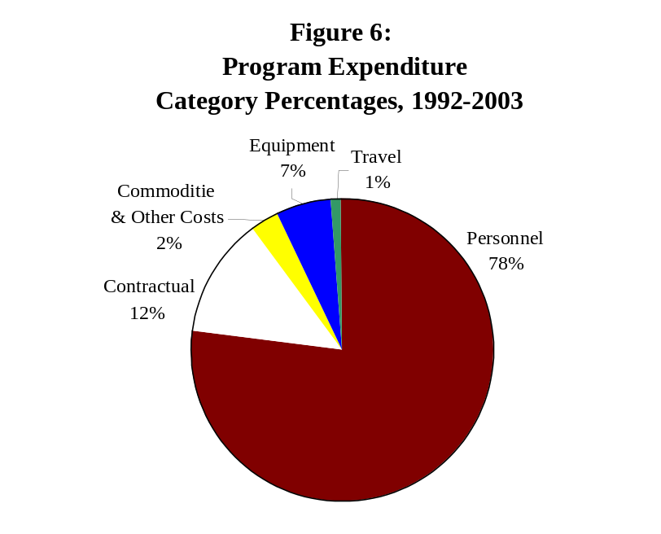

The chart above illustrates how the vast majority of the Council’s funds are used to support the people who make the programs work.

The Council’s grant programs currently support a total of 110 persons. This number includes:

~ 71 investigators and auditors that perform sworn and civilian investigative functions;
~ 18 assistant state’s attorneys prosecuting motor vehicle theft and insurance fraud cases;
~ 14 support personnel including data input operators, clerical support, and others; and,
~ 7 technical and professional positions including intelligence analysts, social workers, intake specialist and law
clerks.

Do grantees “match” Trust Funds?
It is important to note that nearly all of the funded programs also involve considerable “matching” from participating agencies. For example, in terms of the task forces, local agencies are reimbursed for officers assigned at an “entry level” salary as opposed to their actual salary.
The Illinois State Police and the Secretary of State Department of Police assigned seven task force directors and 20 other personnel to their programs without requesting funding. Similarly, the National Insurance Crime Bureau is not compensated for their personnel assigned to the programs.
Many agencies have also contributed office space and furnishings, surveillance equipment and vehicles, radios, and consumable supplies, even if they did not contribute personnel to the program. In other words, the programs funded by the Council are truly cooperative ventures.
The majority of awarded funds have gone into the law enforcement programs that increase investigations and prosecutions of vehicle theft-related crimes. The Council’s funding strategy since 1992 is depicted in the following chart:
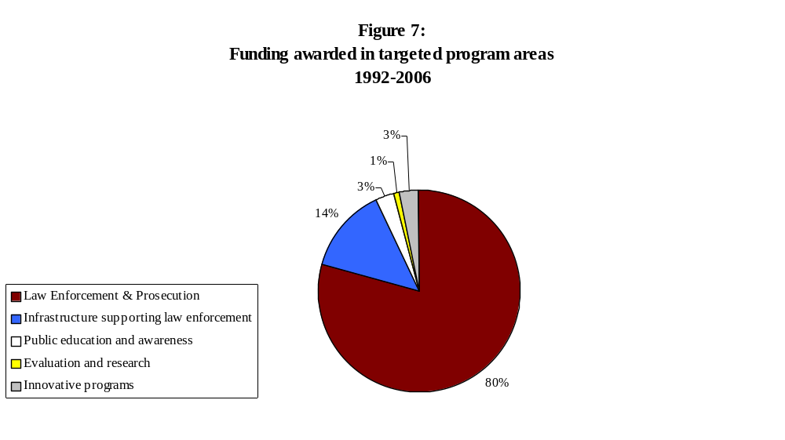Areas of greatest need
Motor vehicle theft data continues to indicate that the top five metropolitan areas of volume of motor vehicle theft, are:
1. The greater Chicago Metropolitan Area including Cook, DuPage, Kane, McHenry, and Lake Counties
2. The greater Joliet Metropolitan Area including Will, Grundy, and Kankakee Counties
3. The greater East St. Louis Metropolitan Area including St. Clair and Madison Counties
4. The greater Rockford Metropolitan Area including Winnebago and Boone Counties
5. The greater Peoria Metropolitan Area including Peoria, Tazewell, and Woodford Counties.
6. The greater DuPage and Kane County Areas.
7. The greater Sangamon County Areas.

The Council has determined that an effective statewide strategy must include involve efforts in the areas of the state where the problem is most prevalent. Public hearing testimony and data analysis support the notion that motor vehicle theft is largely concentrated in the urban areas of the State.

The Council determines these seven areas to be the areas in greatest need of motor vehicle theft prevention program activities for 2008-2011. Motor vehicle thefts in the counties of Cook, DuPage, Lake, Will, Kankakee, and Peoria dropped in 2001 from 1997, and the Peoria and Rockford metropolitan motor vehicle thefts also dropped during that period. To the extent feasible, all programs the Council funds should have a direct impact on the theft problem in these areas.

Table 14:

Percent Change and Funds Allocated For 2005 and 2006
Program | 2005 | 2006 | % Change
Secretary of State Special Audit Teams Program | $1,143,302 | $1,196,236 | 4%
Motor Vehicle Theft Prosecution Unit | $589,315 | $715,797 | 17%
Tri-County Auto Theft Task Force | $783,124 | $800,124 | 2%
Metro East Auto Theft Task Force | $619,176 | $619,176 | 0%
Kane County Auto Theft Task Force | $425,633 | $407,608 | -4%
Northeast Metro Auto Theft Task Force | $746,345 | $618,589 | -20%
Insurance Vehicle Expense Fund Program | $63,590 | $63,590 | 0%
Motor Vehicle Theft Intelligence Clearinghouse | $320,667 | $335,876 | 5%
DuPage County Auto Theft Task Force | $298,534 | $414,735 | 28%
Northern Illinois Auto Theft Task Force | $500,933 | $540,733 | 7%
Motor Vehicle Theft Investigation Training | $88,049 | $88,049 | 0%
State and Local Auto Theft Enforcement | $318,278 | $380,778 | 16%
TOTAL | $5,896,946 | $6,254,055 | 6%

Conclusions
The goals of the 2008 - 2011 Statewide Motor Vehicle Theft Prevention Strategy are to prevent, combat, and reduce motor vehicle theft in Illinois; and to improve and support motor vehicle theft law enforcement, prosecution, and administration of motor vehicle theft laws by establishing statewide planning capabilities for and coordination of financial resources. The Council’s staff is charged with implementing this statewide strategy through encouraging, soliciting, and assisting program development efforts, which address the priorities specified herein.
Limited Motor Vehicle Theft Prevention Trust Funds do not permit every identified problem to be addressed. Therefore, it is necessary to propose a strategy that can be implemented and that encourages programs that will show results within the life of the Trust Funds, that are affordable, and that will maximize the return on dollars that have already been invested to address the problem, and will be invested in the future.

APPENDIX A

THE ILLINOIS MOTOR VEHICLE THEFT PREVENTION ACT
(20 Illinois Compiled Statutes 4005)
4005/1 Title. This Act shall be known as the Illinois Motor Vehicle Theft Prevention Act.
4005/2 Purpose. The purpose of this Act is to prevent, combat and reduce motor vehicle theft in Illinois; to improve and support motor vehicle theft law enforcement, prosecution and administration of motor vehicle theft laws by establishing statewide planning capabilities for and coordination of financial resources.
4005/3 Definitions. As used in this Act:
(a) “Authority” means the Illinois Criminal Justice Information Authority.
(b) “Council” means the Illinois Motor Vehicle Theft Prevention Council, established within the Authority by this Act.
(c) “Trust Fund” means the Motor Vehicle Theft Prevention Trust Fund.

4005/4 Motor Vehicle Theft Prevention Council - Members - Chairman - Terms - Meetings. There is hereby created within the Authority an Illinois Motor Vehicle Theft Prevention Council, which shall exercise its powers, duties and responsibilities independently of the Authority. There shall be 11 members of the Council consisting of the Secretary of State or his designee, the Director of the Department of State Police, the State’s Attorney of Cook County, the Superintendent of the Chicago Police Department, and the following 7 additional members, each of whom shall be appointed by the Governor: a state’s attorney of a county other than Cook, a chief executive law enforcement official from a jurisdiction other than the City of Chicago, 5 representatives of insurers authorized to write motor vehicle insurance in this State, all of whom shall be domiciled in this State.
The Governor from time to time shall designate the Chairman of the Council from the membership. All members of the Council appointed by the Governor shall serve at the discretion of the Governor for a term not to exceed 4 years. The initial appointed members of the Council shall serve from January 1, 1991 until the third Monday in January, 1995 or until their successors are appointed. The Council shall meet at least quarterly.
4005/5 Compensation of Members. Members of the Council shall serve without compensation. All members shall be reimbursed for reasonable expenses incurred in connection with their duties.
4005/6 Personnel. The Executive Director of the Authority shall employ, in accordance with the provisions of the Illinois Personnel Code, such administrative, professional, clerical, and other personnel as may be required and may organize such staff as may be appropriate to effectuate the purposes of this Act.
4005/7 Powers and Duties of Council. The Council shall have the following powers, duties and responsibilities:
(a)To apply for, solicit, receive, establish priorities for, allocate, disburse, contract for, and spend funds that are made available to the Council from any source to effectuate the purposes of the Act;
(b)To make grants and to provide financial support for federal and state agencies, units of local government, corporations, and neighborhood, community and business organizations to effectuate the purposes of this Act;
(c)To assess the scope of the problem of motor vehicle theft, including particular areas of the state where the problem is greatest and to conduct impact analyses of state and local criminal justice policies, programs, plans and methods for combating the problem;
(d)To develop and sponsor the implementation of statewide plans and strategies to combat motor vehicle theft and to improve the administration of the motor vehicle theft laws and provide an effective forum for identification of critical problems associated with motor vehicle theft;
(e)To coordinate the development, adoption, and implementation of plans and strategies relating to interagency or intergovernmental cooperation with respect to motor vehicle theft law enforcement;
(f)To promulgate rules and regulations necessary to ensure that appropriate agencies, units of government, private organizations and combinations thereof are included in the development and implementation of strategies or plans adopted pursuant to the Act, and to promulgate rules or regulations as may otherwise be necessary to effectuate the purposes of the Act;
(g)To report annually, on or before April 1, 1992 to the Governor, General Assembly, and, upon request, to members of the general public on the Council’s activities in the preceding year; and
(h)To exercise any other powers that are reasonable, necessary, or convenient to fulfill its responsibilities, to carry out and to effectuate the objectives and purposes of the Council and the provisions of this Act, and to comply with the requirements of applicable federal or State laws or regulations; provided, however, that such powers shall not include the power to subpoena or arrest.
4005/8 Motor Vehicle Theft Prevention Trust Fund. (a)A special fund is created in the State Treasury known as the Motor Vehicle Theft Prevention Trust Fund, which shall be administered by the Executive Director of the Authority at the direction of the Council. All interest earned from the investment or deposit of monies accumulated in the Trust Fund shall, pursuant to Section 4.1 of the State Finance Act, be deposited in the Trust Fund.
(b)Money deposited in the Trust Fund shall not be considered general revenue of the State of Illinois.
(c)Money deposited in the Trust Fund shall be used only to enhance efforts to effectuate the purposes of this Act as determined by the Council and shall not be appropriated, loaned or in any manner transferred to the General Revenue of the State of Illinois.
(d)Prior to April 1, 1991, and prior to April 1 of each year thereafter, each insurer engaged in writing private passenger motor vehicle insurance coverages which are included in Class 2 and Class 3 of Section of the Illinois Insurance Code, as a condition of its authority to transact business in this State, may collect and shall pay into the Trust Fund an amount equal to $1.00, or a lesser amount determined by the Council, multiplied by the insurer’s total earned car years of private passenger motor vehicle insurance policies providing physical damage coverage written in this State during the preceding calendar year.
(e)Money in the Trust Fund shall be expended as follows:
(1)To pay the Authority’s costs to administer the Council and the Trust Fund, but for this purpose in an amount not to exceed ten percent in any one fiscal year of the amount collected pursuant to paragraph (d) of this Section in that same fiscal year.
(2)To achieve the purposes and objectives of this Act, which may include, but not be limited to, the following:
(A)To provide financial support to law enforcement and correctional agencies, prosecutors, and the judiciary for programs designed to reduce motor vehicle theft and to improve the administration of motor vehicle theft laws.
(B)To provide financial support for federal and state agencies, units of local government, corporations and neighborhood, community or business organizations for programs designed to reduce motor vehicle theft and to improve the administration of motor vehicle theft laws.
(C)To provide financial support to conduct programs designed to inform owners of motor vehicles about the financial and social costs of motor vehicle theft and to suggest to those owners methods for preventing motor vehicle theft.
(D)To provide financial support for plans, programs, and projects designed to achieve the purposes of this Act.
(f)Insurers contributing to the Trust Fund shall have a property interest in the unexpended money in the Trust Fund, which property interest shall not be retroactively changed or extinguished by the General Assembly.
(g)In the event the Trust Fund were to be discontinued or the Council were to be dissolved by act of the General Assembly or by operation of law, then, notwithstanding the provisions of Section 5 of the State Finance Act, any balance remaining therein shall be returned to the insurers writing private passenger motor vehicle insurance in proportion to their financial contributions to the Trust Fund and any assets of the Council shall be liquidated and returned in the same manner after deduction of administrative costs.
The Act is repealed effective January 1, 2008.
(Source: Public Act 86-1406, eff. January 1, 1991; as amended by Public Act 88-452, eff. January 1, 1994 and Public Act 89-277, eff. August 10, 1995.)

Hispanic and non-Hispanic are ethnic, whereas white and black are racial, distinctions. These numbers are therefore not broken down into the distinct categories understood by the population at large, white, black or Hispanic. Citizens are understood to be racially white or black and ethnically Hispanic or non-Hispanic by the U.S. government.

